ABUSIVE LANGUAGE ANALYSIS OF NETIZEN COMMENTS
ON GUS MIFTAH’S INSTAGRAM ACCOUNT

SKRIPSI

Submitted in Partial Fulfillment of the Requirements
for the Degree Of Sarjana Pendidikan (S.Pd)
English Education Program

By

SALSABILA
NPM: 2102050051



FACULTY OF TEACHER TRAINING AND EDUCATION
UNIVERSITY OF MUHAMMADIYAH SUMATERA UTARA
MEDAN
2025

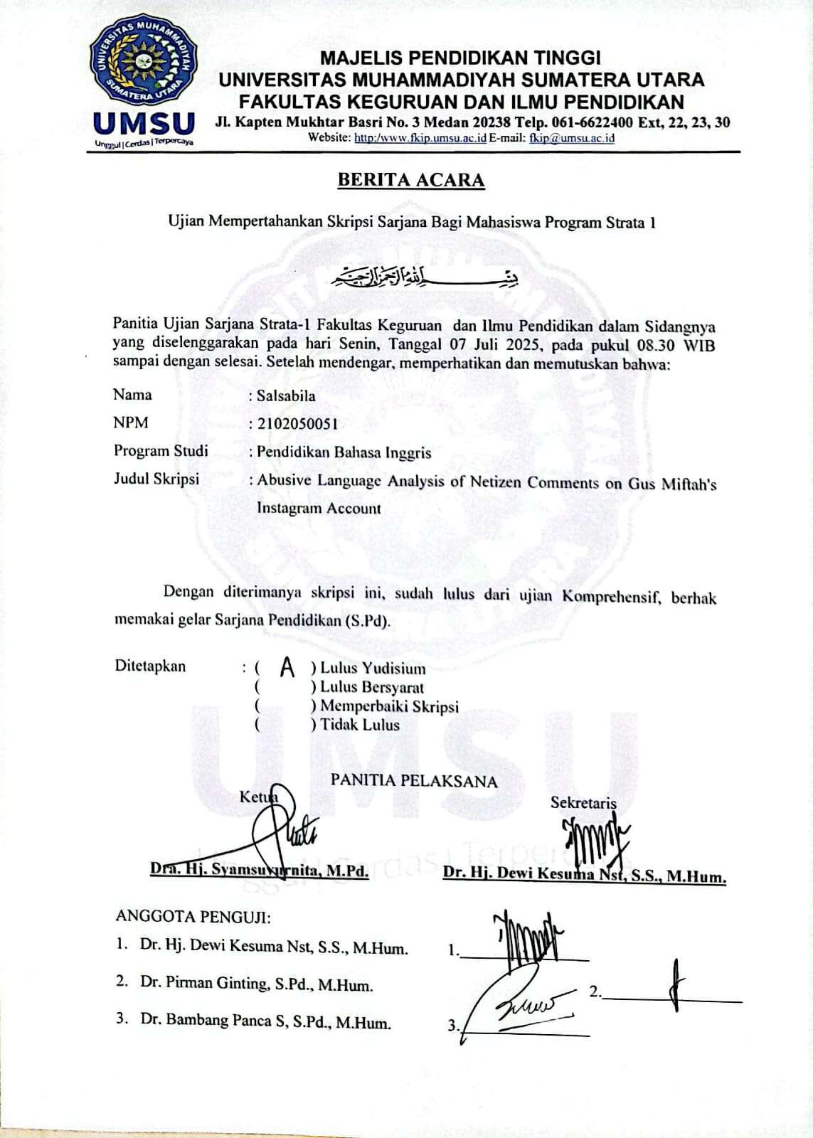
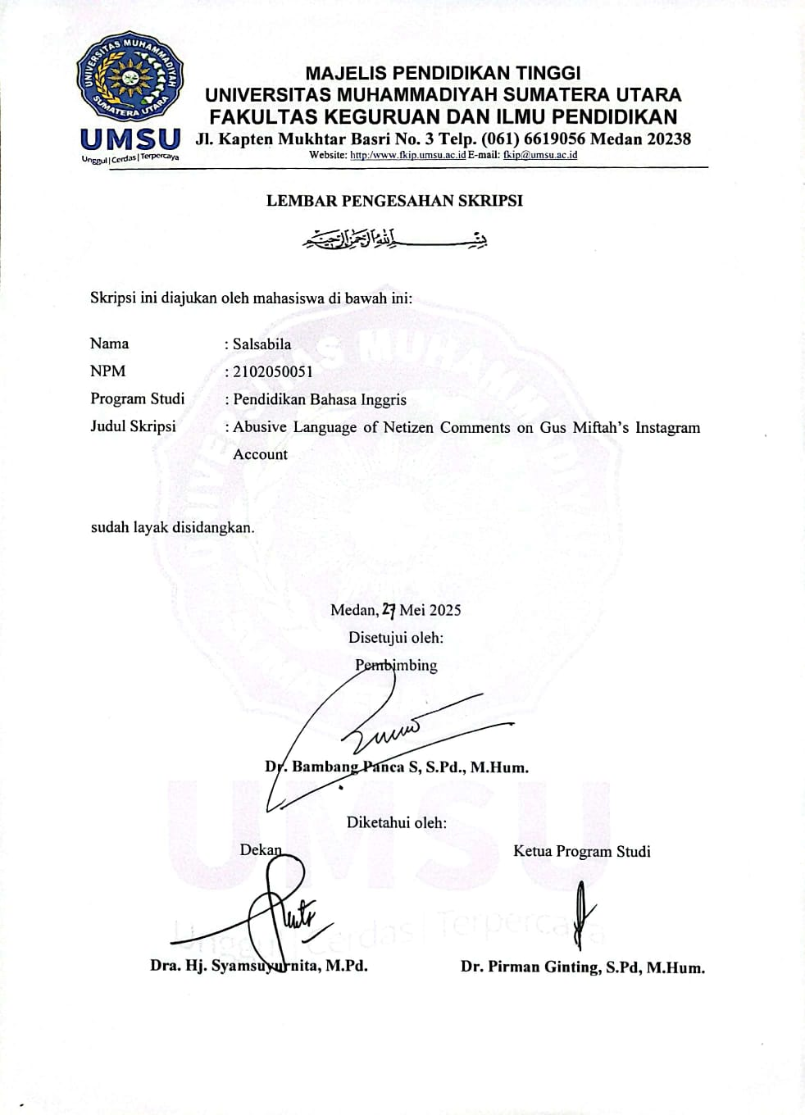
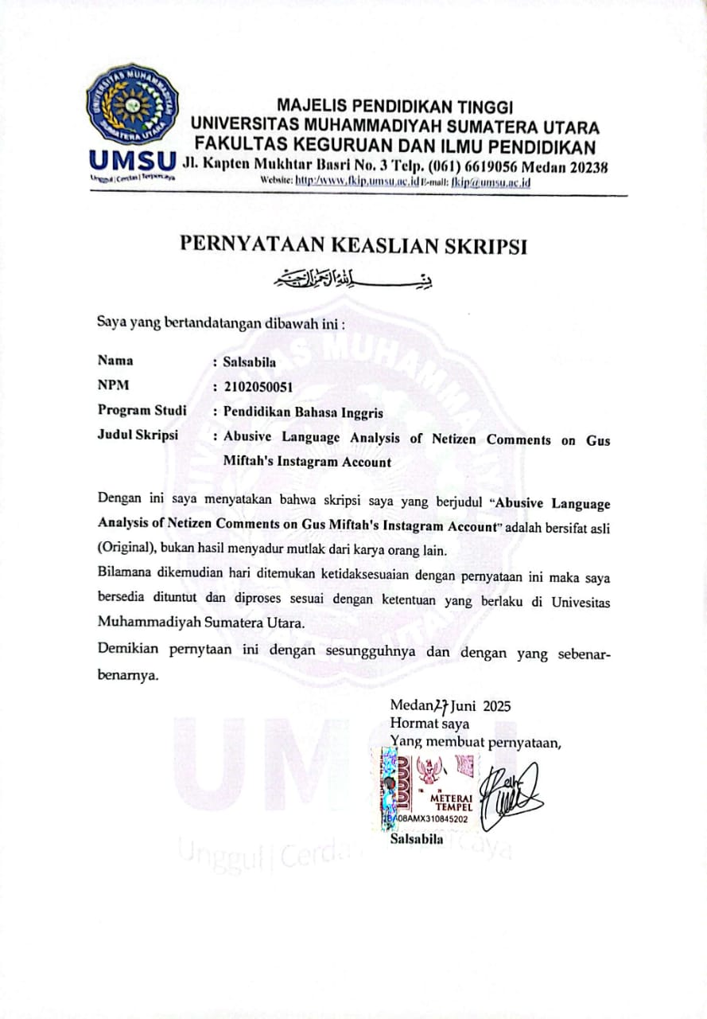
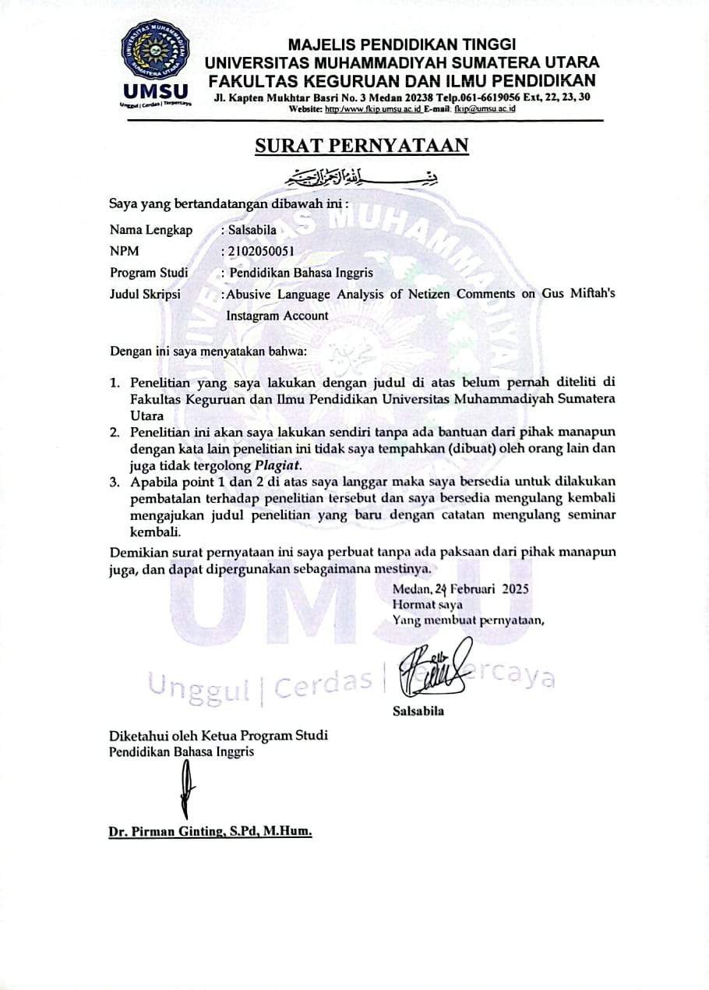
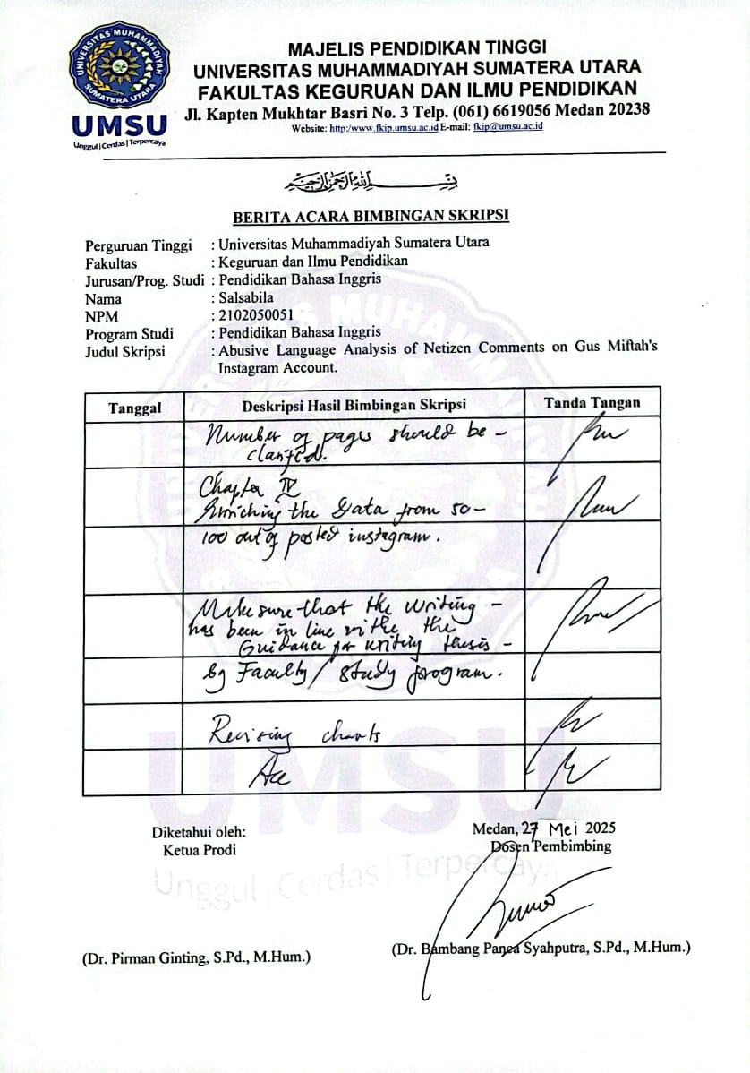

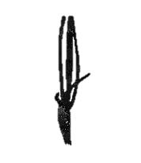

ABSTARCT

SALSABILA. 2102050051. Abusive Language Analysis of Netizen Comments on Gus Miftah’s Instagram Account. Skripsi, Medan: Faculty of Teacher and Training Universitas Muhammadiyah Sumatera Utara.
This study discusses the analysis of abusive language on Gus Miftah's Instagram account that is concerned on investigating the type of abusive language in netizen communication on Gus Miftah Instagram account. The objective of this study is to determine the types of abusive language and explain the process of abusive language used in the comment column of Gus Miftah's Instagram account. This study uses a descriptive qualitative method. The source of the data was obtained from comments of netizen and it was collected by looking at the Instagram comments and taking a note, and the data were analyzed by some steps they were data reduction, data display, drawing and verifying conclusion. There were 100 abusive languages were found in this study. The data was analyzed by identifying comments into 10 types of abusive language, classifying utterances into each type of abusive language. There were 9 types of abusive language were found in the comment column of Gus Miftah's Instagram account, namely Animals Name, Part of body, Profession, Activity, Adjective, Supernatural Creature, Noun, Kinship, and Foreign Language. The researcher found the process of abusive language on Gus Miftah's Instagram Account. The finding showed there were 100 Abusive languages which consist of 14 animals name, 16 parts of body, 11 profession, 14 activity, 22 adjective, 5 supernatural creature, 11 noun, 4 kinship, 3 foreign language and 0 food.

Keywords: Analysis, Abusive Language, Comments on Gus Miftah Instagram Account.

ACKNOWLEDGE


Assalamu’alaikumWr. Wb
In the name of Allah, The Most Gracious and The Merciful.
First and above all, the researcher would like to thank The Almighty Allah SWT the Most Beneficent and the Most Merciful for giving her favors, ideas, and inspiration in accomplishing this study. Also may peace upon our prophet Muhammad SAW, as the figure of good civilizations, intellectual, braveness, loving knowledge. That’s why the researcher has enough ability in writing study. In writing this study entitled “Abusive Language Analysis of Netizen Comments on Gus Miftah’s Instagram Account”.
With the purpose for submitting in partial fulfillment of the requirement for degree in study program of English Department, there were so many obstacles faced by the researcher and certainly without helps from many peoples, especially the following people, it was so difficult for the researcher to accomplish this proposal. This, the researcher would like to express her thank first to her dearest parent, Mr. M. JOHAR and Mrs. ROSMAINI for their pray, advice, courage, moral, and material support from she born until forever and whenever, may Allah SWT always bless and protect them, thanks for their love. Then the researcher also would like to thank:
- Prof. Dr. Agussani, M.AP. as the Rector of universitas Muhammadiyah Sumatera Utara

- Dra. Hj. Syamsuyurnita, M.Pd. as the Dean of faculty of Teacher and Training Education of Universitas Muhammadiyah Sumatera Utara.
- Dr. Hj. Dewi Kesuma Nasution, M.Hum. as the Vice Dean I of Faculty of Teacher and Training Education of Universitas Muhammdiyah Sumatera Utara.
- Dr. Mandra Saragih, S.Pd., M.Hum. as the Vice Dean III of Faculty of Teacher and Training Education of Universitas Muhammdiyah Sumatera Utara.
- Dr. Pirman Ginting, S.Pd., M.Hum as the head of English Education Study Program of Faculty of Teacher and Training Education of Universitas Muhammadiyah Sumatera Utara for his administrative service, so the researcher could finish this research.
- Ms. Rita Harisma, S.Pd., M.Hum. as the Secretary of English Education Study Program of Faculty of Teacher and Training Education of Universitas Muhammadiyah Sumatera Utara.
- Dr. Bambang Panca Syahputra, S.Pd., M.Hum., as the supervisor who has spent a lot of valuable time in correcting and guiding her to complete this research.
- Mr. Adib Jasni Kharisma, S.Pd., M.Hum as the Quality Assurance Unit of English Education Study Program of Faculty of Teacher and Training Education of Universitas Muhammadiyah Sumatera Utara.
- All the lectures and staff of English Department in English Education Study Program of Faculty of Teacher and Training Education of Universitas Muhammadiyah Sumatera Utara.

- My beloved sister Siti Zuriah who gives me support, motivation and remind me to complete this research.
- My HT friends who give her support to finish her study.
- My friends in Class B Morning English Department of Universitas Muhammadiyah Sumatera Utara
Finally, the words can not be enough to expressed, except praise to be Allah the lord of the world, for blessing and guidance. The Researcher realizes that this writing still has imperfections and is nor error free. Hopefully, the findings of this research is expected to be useful for those who read this thesis and interested to the topics. The researcher would like to thank all parties whose names can not be mentioned individually.
Wassalamu’alaikumWr. Wb

Medan, Juli 2025

Salsabila

TABLE OF CONTENT

ABSTARCT i
ACKNOWLEDGE ii
TABLE OF CONTENT v
TABLE OF CHART vii
CHAPTER 1 INTRODUCTION 1
A. Background of Study 1
B. Identification of Problem 6
C. Scope and Limitation 6
D. Formulation of Problem 6
E. The Objectives of Study 7
F. The Significance of Study 7
CHAPTER II REVIEW OF LITERATURE 9
A. Theoretical Framework 9
1. Current issue of communication 9
2. Feature of effective communication 12
3. Abusive Language 15
4. Type of Abusive Language 20
5. Definition of Pragmatic 23
B. Relevant Studies 25
CHAPTER III RESEARCH METHODOLOGY 27
A. Research Design 27
B. Source of Data 27
C. Technique of Data Collection 28
D. Technique of Data Analysis 28
CHAPTER IV RESULT AND DISCUSSION 30
A. Result 30
B. Discussion 52
CHAPTER V CONCLUSION AND SUGGESTION 58
A. Conclusion 58
B. Suggestion 58
REFERENCES 60

TABLE OF CHART

Chart 4. 1 The Result of the Analysis of Abusive Language on Gus Miftah’s Instagram Account 52

CHAPTER 1
INTRODUCTION

A. Background of Study
Communication methods and media have evolved throughout history, from oral traditions to writing, from printing press to radio and television. Each transformation brought unique challenges and opportunities, shaping the societies of their respective eras (Anuashok et al., 2024). The rapid of information technology development has brought rapid changes to the ways of human in communicate. Both in processing messages to be conveyed, the use of media, and how to receive them. Especially, social media has had a significant impact on people’s communication patterns (Nada et al., 2024). The role of social media has become the main platform for individuals to interact, sharing information, and consume content widely and quickly. This phenomenon influences many aspects such as, the way people communicate, shape preference, values, daily life activities. The development of technology information the transmission of social media has become an increasingly relevant and important issue for modern society (Halich et al., 2023). Particularly, the impact of social media platforms, such as Instagram, Twitter or X App, Facebook, TikTok, WhatsApp, Telegram and You tube in general information of public opinion, culture stereotypes and type of users on social media (Alafwan et al., 2023).
Digital communication transformation affects our communication habits and the organizational structures of society. Nowadays, digital communication represents a central element of human interaction (Alexandra & Iacob, 2025). The important component of social interaction is communication. Communication is always used in every aspect, part and areas of human life (Kholia & Sari, 2024). Communication is a process of conveying or exchanging messages between in individuals (Patankar & Deshmukh, 2021). Whether it is done with language, sign, symbol, signal, or other behavior directed from one person to another person (Apriyanto, 2020). Every part of human activity is impacted by communication, and it serve as tool for the development and maintenance of all relationship. Lack of communication can lead to waste and fatal errors (Nabil & Ayubi, 2022). The role of communication between humans is necessary to know its direction and meaning so that a conversation can be digested properly. Communication is very important. Effective communication and understanding of messages are needed for the progress (Nabil & Ayubi, 2022).
Ineffective communication is a complex problem that can have a negative impact on people’s productivity in communicating in public place (Mncina et al, 2024). Furthermore, Joshi (2020) and Bhasin (2023) in (Nabil & Ayubi, 2022) states that communication is used to facilitate in interaction between the parties in conversation. Although, communication is dynamic and influence by environmental factors. The communication is effective if it is two-way interaction (Sharma & Sharma, 2015). Effective communication is interpersonal process and informed by different types of communication, whether in verbal communication the exchange of ideas, thoughts, feelings, opinions, experiences through spoken or written (words and sentences) and non-verbal communication the exchange of ideas, thoughts, feelings, opinions, experiences through sign language and body language (postures, facial movement). Written and visual are shared and understood by the interpret (Buarqoub, 2019). Base on (Narvekar & Sharma, 2024) there are 7 C of effective communication to ensure that you become a good communicator and communicate with your partner most effectively and efficiently. they are; clear, correct, complete, concise, concrete, coherent, and courteous.
In the last two decades, social media has appeared as one of the most influential innovations in the digital era (Hang, 2024). The rapid of technology and the widespread use of the internet have made social media platforms as a part of many people life (Cagatin, 2024). These platforms turn human lives into global village and allow people to engage, interact, and communicate each other instantly, regardless of their location through text messages, images, audio and video call (Noori et al., 2023). Social media is a technology that facilitates the creation and exchange of information and ideas, career, interests and other forms of expression through virtual communication (Sirojiddinova & Solijonova, 2023). Statista (2025) report indicated that in 2025 there were 5.24 billion social media users around the world in early January 2025, equivalent to 63.9 % of the total global population. this widespread use of social media has had an impact on communication (Sirojiddinova & Solijonova, 2023). When we examine the impact of social media on modern communication, it becomes clear that this phenomenon is multifaceted and complex (Anuashok et al., 2024). As a result, this exposure leads to the adaptation and adoption of new lifestyle, which are often influenced by prevailing trends on social media (Nada et al., 2024).
The increasing use of social media, especially young people or teenager, raises a serious concern about safety inclusion in online communication (Kiritchenko et al., 2021). ADL (Anti Defamation League) 2023 survey, 52% of Americans have experienced on social media harassment. Base on the scope of the data sources in the comment column on Gus Miftah’s Instagram netizens bullied him by using informal communication. Informal communication is considered friendly and beneficial to individuals while practicing judgment, and usually informal communication is used in organizations between colleagues, superiors and subordinates (Yadav & Shagun, 2025). Netizens cursed him in a various ways including typing rough comments, stating negative judgment, sexual harassment, rude, sending angry, and the language being vulgar, abusive word/language, cruel statements, untrue, offensive messages, or other dirty phrases, and the most of the comments using informal language (Sitinjak et al., 2023). Finally, based on the related theories, the researcher focuses on abusive language expressed by netizens.
This case developed on online platforms until they become a phenomenon that is worrying would have a big impact in the world. Abusive language on social media is a complex phenomenon that spread very quickly. (Sari et al., 2022) states that abusive language is utterance that contain abusive or dirty phrase. Even not all of abusive language means nasty, but also can be a joke (Diani et al, 2022). Generally, the victims of abusive language are famous people such as, influencers, celebs, youtubers, actresses, actors, big figures, Islamic scholar, and even presidents (Kiritchenko et al., 2021). For example, Gus Miftah’s Instagram account whose case went viral on social media. In this case, a middle-aged man was listening to his Islamic study while selling ice tea that held by Gus Miftah in Magelang. He insulted the ice tea seller with abusive language like “goblok” (dumb) that preacher of Islamic scholars should not speak, because the word is inappropriate or informal, and causes the anger of Indonesian people or netizen.
Regarding this incident, the words conveyed by Gus Miftah would be a problem for the wider community because, Gus Miftah is a public figure, he is an Islamic preacher every action of his will become an example and role model for everyone. Whether they followed him or not. It was feared that his will become a justification. In fact, it was a very fatal mistake. To find out the speaker’s intentions, study of abusive language needs to be carried out, especially in pragmatic approach. Pragmatics focus on contextual meaning, where speaker utter and the listener infer the meaning (Yule, 1996). So, we can understand the meaning of netizen utterances.
Base on the problem, the researcher analyzed abusive language in Instagram comment column in the form of speech as the object of this research. The subject of this research was netizen comments on Gus Miftah’s Instagram account. The researcher chose this study because the researcher wanted to observe how rude or dirty netizen’s language in their communication in the form of abusive language of netizen comments on Gus Miftah’s Instagram account. The Researcher hope that this research would be useful for increasing knowledge about abusive language, and this research could be a reference for someone who wanted to do a research with the same topic.

B. Identification of Problem
The researcher can highlight the key aspects of the research problem as follow:
- Although the sophistication of technology makes human easier to communicate and get information is already known for many people, but the use of internet communication in daily life still needs to be watched out. The unlimitedness of society in using social media causes the language in communication become unprotected.
- People use different types of language in communication and show difference language styles in the use of social media as tools of communication that affects politeness and attitude of their language in communicating.

C. Scope and Limitation
The scope and limitation of this research was investigating cyber communication of netizen comments on Gus Miftah’s Instagram in comment column based on Putra (2013). The researcher examines in two aspects:
- Examines the type of abusive language in verbal abuse and observe how rude or dirty netizen’s language in their communication.
- Using pragmatic approach in assessing abusive language and analyze the meaning of abusive comments expressed by netizen.

D. Formulation of Problem
The formulation of the problem for this study is formulated as follows:
- What type of abusive language netizens comments on Gus Miftah’s Instagram account?
- what is the function of abusive language used by netizens on Gus Miftah’s Instagram Account?

E. The Objectives of Study
The objectives of this study are:
- To investigate the type of abusive language expressed by netizens used one Gus Miftah’s Instagram account
- To investigate the function of abusive language used by netizens on Gus Miftah’s Instagram

F. The Significance of Study
The significance of this study is expected to be useful and relevant in several cases matters both theoretical and practically:
- Theoretically
- The result was contributed to the existing knowledge by providing insight into effective communication in communicating.
- In addition, this study would be useful in study, as a source or references for understanding abusive language and its types expressed by people on their communication especially on social media.
- Improving and expanding the framework for further research in this domain.
- Practically
- For teachers, as a consideration that may be useful and improving knowledge, especially about abusive language and the type of abusive language
- For students, as a reference in learning, and add more knowledge about abusive language, and the type of abusive language
- For readers, to give more information and understanding about abusive language, especially in the type of abusive language that can be a reference in their study

CHAPTER II
REVIEW OF LITERATURE

A. Theoretical Framework

1. Current issue of communication
The advent of industrial revolution 4.0 has triggered a reinvention of telecommunication networks. The transition from 4G to 5G is a major advancement in mobile communications technology, with profound implications for individuals, business and industries (Kumar et al., 2023). Digital technology has enabled individuals from different parts of the world to connect and communicate instantly, in social media (Judijanto & Aryani, 2025). This will help improve communication effectiveness, which is the key to manage mistrust, outcomes, and confusion. Another study identified misunderstanding, including poor communication which were categorized as one of the most critical factors. Miscommunication can occur in various forms, such as slow or late circulation of information, ineffective reporting systems, and lack of communication between speakers and listeners because they come from different background (A.A. Abdallah et al., 2024).
Ziin and Muller (2022) in (Gricar & Tomec, 2023). state there are three risks of language (communication); language barrier, cultural values, and different communication styles.

  - Language Barriers
Language barrier refers to differences in linguistic communication between people who speak different language or have different language background (Paiz, 2017). Language barriers can arise at different levels of languages learning in each level. At the beginning level, language barriers can arise due lack of the knowledge, vocabulary, and grammar skills. It leads to difficulties in understanding and using the language in conversation (Khasueva & kulaeva, 2024). The challenges in language barriers include misunderstanding, lack of clarity, difficulty in build relationship, misinterpretations and ambiguities can lead to strand interaction and impaired conflict resolution (Salih, 2024). Language barrier can be difficult for people to communicate effectively, sharing information, and understand conversations in each part of their life. The existence of language barriers can lead to misunderstanding and intercultural conflicts due the inability to convey thoughts and feelings accurately in another language (Khasueva & kulaeva, 2024).

  - Cultural Values
In different cultures, backgrounds, values, ways of thinking, and behaviors are not the same which causes differences in communication style (Guo, 2020). Cultural values can be one of significant impact in language risk. Different cultural backgrounds can cause misunderstanding, even with the same vocabulary (Ye, 2024). When people from different cultural backgrounds come together, their unique norms cultural values influence how they communicate, interpret, and respond (Gricar & Tomec, 2023). Non-verbal communication was referred as an element through all sources and often perceive cultural value. People from different cultures may experience misunderstanding when they encounter non-verbal behaviors that are unfamiliar to them or interpreted differently (karlik, 2023). In other words, cultural diversity can lead to variations in communication, which can lead to misunderstandings and difficulties in cross-cultural interaction. In conclusion different cultural values create different communication style.

  - Different Communication Style
Human has a mode or style in communicating based on the norms, rules, and cultural values. (Torre Gabriel G. de la, 2021) states Some of communication differences facilitate relationship with others, while others make a difficult interaction in communicate and develop good personal relationship. Communication styles affect how people interact, exchange information, collaboration, and so on (Torre Gabriel G. de la, 2021). Nordin (2021) state, language risk as a complex process involving the exchange of information and ideas between individuals with different cultural backgrounds is also influenced by communication style (Gricar, 2023). Communicating with people from different cultures, cross-cultural misunderstanding will occur because of certain words, gestures, social context and everything in our mind has different meaning in each culture (Okira et al., 2022). Communication style is all of the characteristic of person’s communication behave with their personality, temperament, culture, and social environment where they live (Sunardi et al., 2020). Communication style shows how people understand and evaluate information in their environment.
Human communication is a process of social interaction. Communication is the process of creating, exchanging, sharing ideas, information, opinions, facts, feelings, and experiences between speaker and listener (Machfudi, 2023). It is a fundamental to the existence of individuals, groups, societies, and nation (Buarqoub, 2019). Language barrier, cultural values, and different communication style can create problems of miscommunication, such as misunderstanding, misinterpretation, distorted messages, misinformation, confusion, mistrust, conflict among people and etc. they can be factors that hinder effective communication.

2. Feature of effective communication
The term of communication derived from the word “Communes” which means to share. Effective communication in an open environment, and it is essential for providing feedback from the interlocutors. Wilbur Schemamm (1954) in his book “How communication work?” states, the main reason we study communication process is to find out how communication effects both individuals and groups of people to find out whether the feedback from communicant is accordance with what we want (Lewar et al., 2023). Communication is dynamic process that begins with the conceptualization of idea by the sender who send the messages to the receiver and provides feedback (Patankar & Deshmukh, 2021). Effective communication is the foundation of successful interactions and collaborations in various of fields, including health care business, education, and international relations (Salih, 2024).
Along with the advancement of communication in technology and rapid of information spread through various online platforms. We should not have a positive or negative attitude towards internet language, but create a condition that can maximize the effectiveness (Yang, 2024). (Buarqoub, 2019) in his research states, effective communication is difficult to achieve. In today’s globalization world, effective communication is essential to build relationship. Language can act as a bridge in communication with people and a wall that prevents people from exchanging messages simply, clearly, and accurately. Ineffective communication, negatively affects people relationship (Mncina et al, 2024). Society still faces problem of ineffective communication, such as rigidity, indifference, and lack of attention (Putri et al., 2024). Effective communication encourages the exchange of ideas and fosters creativity, but when communication barriers arise, it leads to missed opportunities for an innovation. Additionally, persistent communication problems can lead to frustration and stress, which negatively impact productivity and job satisfaction (Abalogu et al., 2024).
Communication can be made effective by using technology which acts as a source of power to enhance communication style. Effective communication is a combination of a set of skills that include attentive listening, non-verbal communication, ability to cope with stress in the present situation, and the capability to identify and understand one’s own emotions and person with whom is communicating (Sharma & Sharma, 2015). Effective communication is when messages conveyed by the sender and understood by the receiver exactly in the same way as intended. Both the sender and the receiver feel satisfied (Yodiansyah, 2024). Effective communication is not only about delivering messages clearly, but also understanding the recipient’s mental framework (Babasoy, 2025). In addition, the clearest messages can be colored by the receiver’s state of mind and make effective communication become dynamic and sometimes challenging.
Poor or ineffective communication usually leads to misunderstanding or misinformation. (Narvekar & Sharma, 2024) classify effective communication into 7 C’s:
- Clear, clear communication is considered as indispensable. They are able to convey ideas, perspectives, viewpoints, and information in an appropriate manner which can easily to understand (Kapoor, 2020).
- Correct, the sender makes sure that her communication is correct. Language structure of the messages must be accurate and perfect, Both grammatically and mechanically. The correct massages have a good impact on the receiver (Ramakhrishnan, 2018)
- Complete, the communication must be complete. conveying all messages, facts, and information.
- Concise, it conveys a messages or idea using a few words as possible without losing the essence of the messages. The aim is to avoid unnecessary details or information (Porwal, 2023).
- Concrete, concrete ideas will give a better result in statement. So, the receiver can understand our message directly (Narvekar & Sharma, 2024)
- Coherent, the communication must have logical flow to be effective. Making it relevant and engaging. This will help the receiver keep the topic, whet we want to deliver (Narvekar & Sharma, 2024)
- Courteous, polite communication to the audience with respect and consideration. It includes politely, showing empathy, and refraining from using language or action in manner that is rude or abusive (Porwal, 2023).
Communication can be defined as the transmission of thoughts and information between two or more people through different ways.it can be written or spoken words. The tone, stress, and pitch of voice can make it different. Effective communication is defined by seven principles of communication. People can communicate more effectively and prevent miscommunication.

3. Abusive Language
Since Internet become a place where people can talk to every people, there has been a huge online abusive speech, especially on social media (Mubarok et al., 2024). This problem has been ongoing over the time and will continue to grow. Therefore, abusive language on social media is a particular concern for online communities, government, and social media platforms (Nakov et al., 2021). This is how technology bring advantages and disadvantages (Mubarok et al., 2024). There are many social media users often communicate with abusive and uncontrolled words. Abusive words is one of cyberbullying that could expressed spoken both orally or text (Sari et al., 2 022). It can be in the form of action on social media through comments, that netizens usually used to express their feelings with freely (Hernawati et al., 2024). It can be abusive if contains rude or dirty phrase, and abusive language is often used in the form of informal communication in the context of joke to express affinity (Budi & Ibrohim, 2023).
The use of abusive language is fundamentally related to the cultural context of the speaker (Hafizh, 2018). Therefore, abusive language differs from one culture to another, depending on the various social context and how language itself is influenced by social factors. Therefore, abusive language is included in sociolinguistics. The sociolinguistics theory is related to language theoris regarding the relationship between language and society (Eid & Hamdan, 2021). Sociolinguistic is the study of our everyday life, how language works in our casual communication, the media we are access, and the existence of societal norms, policies, and the laws that address language (Fuller & Wardhaugh, 2015). Sociolinguistics investigate how social factors influence the language use, including the use of abusive language. It includes analyze the social context in which context abusive language is used, the effect of language, and how it relates to social inequalities (Andrus, 2024). This eesearch examining abusive language in relation to social, gender, politeness, age, culture, behavior, and attitudes of the utterances. In other words, this research observe how social cultural conventions are expressed in language (Eid & Hamdan, 2021). It can be expilict, using swear words or insult, and implicit relying on subtle cues or convey negativity (Vidgen et al., 2019).
In Indonesia, abusive language or dirty phrase usually come from something bad, disgusting or taboo to speak in public. As recorded by (Akhter et al., 2020) state abusive language is utterance or expression that contains a bad or dirty words in conversation. People often spread hate speech accompanied with abusive language (Davidson et al., 2017). Abusive language means inappropriate words or speech in the term of rude words, cursing, yelling, shouting dirty phrases which are expression of people’s emotion (Diani et al, 2022). Abusive language is a form of expression that insult other people by using indecent words (Hayaty et al., 2020). Abusive language can be act of verbal violence because of the expression hurt other people’s feelings (Darida & Koller, 2020). Putra (2013) in (Iman & Salim, 2022) states Abusive language is not dangerous if it used for telling stories and joking, but they can cause problems when it used as an attack. We often see or read abusive language on social media to express hatred, insult, and excetra (Mashkoor & Sher, 2024).
The use of abusive language is increasingly and entrenched among society, especially teenager who are one of the most internet users (Hannako et al., 2024). It is not only as a trend or style in communication, but it has become a habit and tradition that undermines the communication, morals and character of Indonesian generation (Khalid et al., 2016). It has become more natural and normal as everyday language in communication (Budi & Ibrohim, 2023). The lack of binding laws makes the use of abusive language commonplace or normal (Hernawati et al., 2024). One of the cases that sparked both polite and rude comments on social media was a case of insults committed by preacher and leader of the Ora Aji Islamic boarding school in Sleman, against an ice tea seller in his study. from this information, haters flocked to bombard his Instagram account with abusive words, insulting and provocative. It leads to hatred in social spaces.
There were many reasons behind abusive comments (taboo words) expressed by netizen in social media (Khalid et al., 2016). People abuse to someone who was doing something wrong to express their feeling (Ena & Wene, 2020). As recorded by Friyanto & Ashadi (2020) referring to sociolinguistics studies, abusive word in Indonesian can be influenced by everyday conversation (Sari et al., 2022). It describes an unpleasant situation or condition (crazy, stupid, idiot), compare animals characteristics with human (dog, Pig), connect about astral (Satan devil), an object with bad references (shit, feces), part of body that related to sex activity or a usual part of body (eyes, brain, mouth), related with family member and add suffix (your father, your mother, your grandpa), using a low profession (clown, bitch, shaman,) (Sari et al., 2022). Whenever abusive language used to attack people in verbally it causes social problems because, using abusive language negatively impacts a person’s social life and people who use abusive language are considered as illiterate and impolite person (Mashkoor & Sher, 2024). In positive side, abusive language may not violate the law. for example, they use it as an aid in expressing deep emotion about something, helpful in cracking joke and humor in social circle or close friends (Mashkoor & Sher, 2024). In this case, it can be said that abusive language is also taboo language, which is the language can be abusive/rude and impolite to use in social conversation depend on the intent and purpose of the word when it spoken by speaker (Setiawan & Rahayu, 2021).
Anderson and Trudgill (1992) in (Iman & Salim, 2022) classify abusive languages in to four functional categories, namely; Expletive Function, Abusive function, Humor Functions, Auxiliary Function.
Expletive Function, it expresses personal emotions. it means the use of swear words to express emotion such as, anger, frustration or hatred and, it’s not directed to anyone (Prayuda et al., 2019). For example, when someone is hit by something or startled by a situation, he will say “shit”, “damn”, “fuck”, and etc. those words are abusive words, because he does not direct his words to anyone. The word just come out when he faced unwanted situation.
Abusive function, it uses to insults and aimed directly to other people. Abusive is a swear word that directed to another person (Prayuda et al., 2019). This kind of abusive word is always uttered by someone to another person, and to whom he can say the abusive language. For example, the speaker curses the target “You Idiot”, “bitch”, “bastard”, “asshole” and etc. Those abusive words are widely used among society.
Humor Functions, it means, referring insults directly to others, but not with the intention of insulting (jokes). Even it is considered as taboo or impolite words, but it’s popular among male and female, young or old. When chatting with friends or to close person, consciously or unconsciously, they use abusive words in communication activity as a function of sarcasm or jokes, and as a form of closeness. For example: “stupid”
Auxiliary Function, namely the use of insults is not directed directly to particular person or situation. It is the way of talking, and not serious because applied empty meaning (Prayuda et al., 2019). Auxiliary swear words are used as empty meaning, and said in emphatic tone. In daily life, people use swear words are quite common. Anderson and Trudgill said it as “lazy swearing”, because it has no meaning, For example: “Anjir”.

4. Type of Abusive Language
The function of abusive language is very complex (Ena & Wene, 2020). Most of people used abusive language to vent their emotions and turmoil straightforwardly. When someone is angry, he will say abusive language without realize it (Mashkoor, 2014). Moreover, abusive language is also as a pride or symbol for certain groups as self-identity. Usually, abusive language is used by teenagers (Hannako et al., 2024). Abusive language can also be used as a way to express feeling or aggression without violence.
Base on Putra (2013) in (Iman & Salim, 2022), state there are many types of abusive language, namely:

- Using Animals name
Animals are living creature that use instinct and live in open environment. Many Animals live side by side with human, but there also many animals are shunned by human because they are considered the damage or bad for health or shunned of religion. Due the negative nature of some animals, many teenagers and community used them as abusive words. Animals name that are often considered to used are dirty, unclean, savage, bad or ugly.
For example: dogs (anjing), pigs (babi), and monkeys (monyet), and etc.
- Using parts of body
Parts of body are part of human body. They have their own respective function. Not all parts of body can be mention in public, because the names of body parts that are often to used, usually are not worthy or impolite to said in public.
For example: dick (kelamin pria), pussy (kelamin wanita), brain (otak) and etc.
- Using types of Profession
The types of profession in abusive language can be in the form of using words that refer to a profession or job to insult, demean, or embarrass someone. The professions are considered negative by society.
For example: Prostitute (pelacur), bitch (jalang), gigolo (gigolo), pimp (germo), and etc.

- Using types of activity
Activity carried out by human in interaction. The activities are activities that would be inappropriate or impolite words that refer to activities to insult, demean, or embarrass other people.
For example: Bastard (bajingan), jerk (brengsek), fuck (bersetubuh) fag (homo) and etc.
- Using types of adjectives
These abusive languages are taken from adjective that have a bad meaning. So, if they are thrown to someone, they will seem rude and definitely hurt the feeling of the person they are talking to. The adjective has bad impression if thrown to someone.
For example: idiot (idot), Stupid (bodoh), wacky (goblok), brainless (gak ada otak), fuck (persetan), and etc.
- Using types of supernatural creature
Supernatural creatures are creature that cannot be seen and often used to curse among teenagers and community, because the meaning the words contain negative traits.
For example: satan (setan), and etc.
- Using types of kinship
Kinship names are also used in curse. This is based on the assumption that someone will easily feel offended, if the names of their family or relatives are made fun in a certain matter.
For example: mother and father’s name (nama ibu atau ayah), and etc.
- Using type of nouns
Feces is food dregs from stomach that comes out through the rectum in various dirt or items that are considered as dregs.
For example: feces/shit (tahi/kotoran), and etc.
- Using types of foodFood is an energy enhancer for humans. In Indonesia manyfoods are also used as abusive word/ swear words. For example, the word “asem/lontong” to express annoyance
- Using a foreign language
The uses of foreign languages as insults among teenagers has become commonplace. The foreign language is a language that has a rough meaning that comes from various countries, such as America, Korea, England, Russia, Japan and etc.
For example: fuck (persetan), shit (kotoran/omong kosong), damn (brengsek), asshole (bajingan), bastard (bajingan), bitch (pelacur), motherfucker (bajingan), hell (jahanam), cyka blyat (wanita penghibur), sshi-bal (sialan), gae sae-kki (bjingan/anjing), ji-ral (omong kosong), hentai (mesum).

5. Definition of Pragmatic
Linguistically, pragmatics discusses meaning in context (Diani et al., 2022). In addition, paying attention to politeness people who engages in activities and communication must pay attention to politeness ethnics and context (place or situation). Base on George Yule pragmatic is the study of contextual meaning and the speaker meaning. This study also examines how context influences the meaning of what is said (Yule, 1996). Understanding the meaning and purpose of speech for effective communication or it can lead to misunderstandings that lead to conflict and verbal abuse (Diani et al., 2022). Pragmatics analyzed the language form and the speaker intention of how language is used in social communication (Dipta et al., 2024). In pragmatic we study about speaker’s intentions, how the meaning is communicated based on the intent. Austin defined about pragmatic as the study of the use of language in social context and how people interpret the meaning through language (Austin, 1962). This study evaluate of how human language is used in social interaction and the relation between the speaker’s utter the language and how listener interpret the meaning communication (Eragamreddy, 2024). The phenomena of pragmatic include speech acts, relevance in communication, verbal and nonverbal (Muhammed, 2022).
Pragmatic studies can be known through the implicit and explicit meanings in pragmatic understanding (Frank & Manuel, 2019). Explicit means the meaning is relate to context-bound, and implicit means there are a hidden meaning, or the meaning rises because there is something different from what was said (Levinson, 1983). Pragmatics can also be interpreted as the study of the relationship between language, context or understanding. because pragmatic will help us to understand the deeper meanings than the literal meaning of the words (Al-Shaikhli et al., 2020). Pragmatic studies also help us to understand the thoughts of the speaker and the correlation between sentences and the context (Dirham & Triyuono, 2023).
Thomas (1995) mentions 2 pragmatic tendencies in her book about meaning in interaction. First, social perspective and second cognitive perspective. To be specific:
- Social perspective, connecting with pragmatic meaning of the speaker (the meaning of the speaker).
- Cognitive perspective, connecting with pragmatic interpretation of utterances (utterances interpretation).
It means that, the meaning of the speaker’s speech is dynamic and involve a negotiation between the speaker and the listener. So, we can’t judge the meaning of someone’s words, because there were several contexts that we need to be aware of. Pragmatics examines on what is not stated directly, and how someone interprets an utterance in situational context. They do not concern the real meaning of what is said, but it is about what is communicated through the manner and style of speech
Studying language through pragmatics leads us to know the essence of language (Eragamreddy, 2024). It leads to in-depth analysis of what message is carried out in utterances that utter by the speaker. It can provide and discuss people’s intended meaning, their assumption, their goals and the action performed by the utterance.

B. Relevant Studies
There are some previous studies which is related this study, to support this proposal as follow:
- Ralat Bahasa Kasar Pada Sosial Media: Stilistika Atau Ujaran Kebencian? by Nuryansyah Adijaya, Hafizah, Ninuk Lustyantie, and Ifan Iskandar university of Borobudur, University of Bhayangkara Jakarta Raya, and University of Negeri Jakarta. Base on this study, the researchers found several categories of abusive language that are often used on social media in Indonesia: circumstance/situation, animals, supernatural creature, physique, profession and etc. The relevant of this study with my research was the types of abusive language, but the different in my study is more complete. Not only for the type but also for the function and how to understand abusive language.

- Abusive Language: Reasons And Consequences by Iffad Khalid, Shazia Gulzar and Rooh Ul Amin Gomal University, Pakistan. The result of this study was, the researchers found five super ordinate themes such as, Abusive language is a normal language, Family/friends/society prevailing abusive language, as a trend, inner peace/satisfaction and happiness. It is related with my study, because it discusses about how teenager and society use abusive language in their communication. In my study, it will be different because I used some journals from Indonesia and society itself, as I investigate the communication form of Indonesian society to support my study and pragmatic side to understand the meaning.

CHAPTER III
RESEARCH METHODOLOGY

A. Research Design
This study investigated abusive language on Gus Miftah’s Instagram account through applying descriptive qualitative method. The purpose of descriptive research was to describe a phenomenon and the characteristics. This research was concerned with what and why questions in research and mostly the data regarding feelings, perception and emotion (Nassaji, 2015). Therefore, observation and survey were used to collect the data. Qualitative research involves in collecting and analyzing non-numerical data to produce insights, such as text, audio, or video (Eze & Ugwu, 2023). It was semi-structured or unstructured. After collected the data, the researcher would analyze the data with qualitative method, which was the researcher expect to understand the phenomenon of what is happening to the subject. This research design was intended to investigate the type of abusive language and the process of abusive language on Gus Miftah’s Instagram account.

B. Source of Data
The source of the data was taken from netizen comments on Gus Miftah’s Instagram account, namely @gusmiftah which is indicate to the abusive language. Gus Miftah or known as Miftah Maulana Habiburrahman (born August 5, 1981). He is a preacher and leader of Ora Aji Islamic Boarding School in Sleman. Gus Miftah is known as an eccentric kyai from Yogyakarta. He is also known as a young preacher of Nahdlatul Ulama (NU) whose focus in preaching inside and outside Islamic Boarding School. The researcher would analyze 10 Instagram posts from Gus Miftah and take 100 abusive languages made by netizens in Gus Miftah’s Instagram comment column. The date was on 29th November 2024, 30th November 2024, 2nd December 2024, 5th January 2025, 8th January 2025, 10th January 2025, 12th January, 13th January 2025, 19th January 2025 and 8th February 2025.

C. Technique of Data Collection
- First, open Instagram App.
- The researcher searches Gus Miftah account, namely @gusmiftah.
- Then, chose 10 good of Gus Miftah posts.
- The researcher reads and select comments that are indicate as abusive language.
- Make notes of abusive language that has been collected by the researcher
- Finally, the researcher analyzed the abusive language from netizen comments on Gus Miftah’s Instagram

D. Technique of Data Analysis
After collecting the data, the researcher would use data analysis technique which was depeloved by Huberman and Miles. (Huberman & Miles, 2014) states there were three activities in qualitative data analysis namely, data reduction, data display, and data conclusion drawing/verification.
- Data Reduction
Data reduction aims to process a raw data that comes in written field notes to be analyzed. The process can be in the form of selection, focusing, simplifying, abstracting, and transformation. The first step of data reduction was the data selection. The text would be separated into sentences. The data analysis wouldl be described in tabulations and accompanied by research findings.

- Data Display
Data display can be done in various form such as tables, graphs, and etc. in addition, data display (presentation) can be done in the form of brief descriptions, charts, relationship between categories and flow charts and etc. By displaying the data, the Researcher can easily understand and analyze the data what is happening with the data and the researcher can begin to the next plan of the further research based on what the researcher has experienced.

- Conclusion Drawing of Verification
The final step where the researcher draws the conclusion from the research based on the findings. After did the both steps, the researcher will find the answer from this study case by reading and selecting the comment from Gus Miftah’s Instagram account and analyzing the type of abusive language of each comment that utter by the netizen.

CHAPTER IV
RESULT AND DISCUSSION

A. Result
After analyzing the data, it was found that,
- There were nine types of abusive language on Gus Miftah’s Instagram account, they are Animals Name, Part of Body, Type of Profession, type of Activity, types of Adjectives, Supernatural creature, Type of Nouns, Type of kinship, and Foreign Language.
- The process of abusive language was used on Gus Miftah’s Instagram account, Such as:
- Animals name
Animal names refer to the common names to identify difference species of animals. In negative side, it usually compares with individual characteristic. These were some examples of animal name on Gus Miftah’s Instagram account:
- (handato89) ASU WE MIF (You are a dog Miftah)
- (ninot_69) Nyet Miftah (Miftah is a monkey)
- (may_udin27) Cangkem mu koyo asu (Your mouth is like a dog)
- (ricislubis) Naik anjing, naik anjing juga enak (Just ride a dog. riding a dog is also fun)
- (dwijuanitaputri) Pengajian isine cangkeman rusak!! Gus BAB1 TAI MIFTAH (The study is useless, it's ruined!! Gus Miftah is a dump pig)
- (inspirationquote514) Kayak anjing perangai lo (Your behavior is like a dog)
- (elangmerah1) Si anjing playing victim.. Dasar hama (The dog is playing victim. What a pest)
- (riniririn22) Pecat ni Binatang (fired this animal)
- (monkeyd.anto) minimal malu jink (At least you are embarrassed dog)
- (m_alburak) Anak Binatang (Son of bitch)
- (joga_sugiono) Bocah jamet a5u (This jamet is son of bitch)
- (togirls_i) Anjay sidukuuun (Quack dog)
- (mhd_nazier559) Tangisan buaya (Crocodile’s tears (such a liar))
- (1of1kaiee) anak b4b1, keturunan pun b4b1 (You are a piglet. your offspring are the same)
The forms of utterances expressed by speaker 1, 2 and 3 contained abusive language. The utterances were considered rude, ridiculing, insulting words that were not appropriate for human. This could be seen that they called Gus Miftah with animal name “Dog” and “Monkey”. Gus Miftah is a human, but he called as a dog or monkey, which was means his behavior likes animals, wild, cruel and brainless. The utterances of speaker 4 said the word “Dog” means a pet. It is impossible and inappropriate to ride it as a vehicle or stage for speaking in public. The utterances of speaker 5 said, the word “pig” here means that Gus Miftah's is dirty and a disgusting person. The content of his study is just a nonsense. Talking a lot without value or benefit, just talking as pleases. The utterances of netizen 6 The word “Dog” is to described Gus Miftah behavior, which we know that humans and animals totally different. They have different behavior, brains, and it will never be the same. The utterances from netizen 7, 8 and 9 said that society no longer wants to see him anymore as a preacher and influencer, because Gus Miftah is like a pathetic and insolent person. They want Gus Miftah disappear from public activity. The word “jink” is the abusive word of “dog”. This statement is written in slang word or it can say write it in shorten way to pass the netizen intent, and dog is one of animal that can express unclean and dirty. The utterances from netizen 10 and 11 were spoken to express and symbolize as disappointment of society. Speaker 11 wrote his utterance by using numbers in talking and generally it was to avoid inappropriate word in writing, but this word still has the same meaning. It used to curse or insult someone. The word “anjay” written by netizen 12 means “dog”. This word is written in pun (wordplay) without changing the actual meaning. The function of this word is same to insult someone. The utterance from speaker 13 “Buaya” is Crocodile in English. Statement “Tangisan buaya” means people who pretend to be sad or it can say a liar. Netizen said Gus Miftah is a liar. Utterance 14 by netizen 14 means, the word “B4b1” means pig. Using numbers in talking or generally to avoid inappropriate word in writing. but this word still has the same meaning. Netizen cursed Gus Miftah and his family as a member of animals not a human.

- Part of body
Part of body refer to some organs, or structure that makes up the human body. In negative side part of body usually relate to sex activity or another part of body. These were some examples of part of body on Gus Miftah’s Instagram account:
- (dikrihrlg) Halahh k*nT*L emg org ini (This guy really has a bad dick)
- (filham_stillyoung) Halah Jembot Cocote Taim (What the fuck are you talking about pubic hair)
- (celiboyexe) omong kosong otak kopong (Empty brain, what a bullshit)
- (Ramm-ramadan) GAMBLIS E GAK DI CUKUR TA (His pubic hair is not shaved)
- (yudhali_) konntollll gusssss (Fucking you)
- (exelspeed) Gus Jembot (Gus is a pubic hair)
- (sint_arosiana) TAIM ANJING KONTOL (Fucking you, jerk)
- (filham_stillyoung) Halah Jembot Cocote Taim (What the fuck are you talking about pubic hair)
- (zioking53) CERAMAH TAIK G ADA HADIST SOK SOK AN PUKIMAK (Your lecturer is like a shit, motherfucker)
- (muubaraba) Ndasmu ujian (Your head is tested!)
- (byu.3gp) Halah pepek (What a Cunt!)
- (nono_nggg) Ceramahlu isinya selangkangan semua (Your lecturer is full of crotch stuff)
- (frana875) Mememeeeekkkkkkkkkkk (Cunt!)
- (celiboyexe) omong kosong otak kopong (Empty brain, what a bullshit)
- (openshopstore) GAK ADA OTAK (No brain)
- (hhendriansyah) Hilih kintil (What a cunt!)
- (amiialf) kontol ngentoddd yatim tai puki ajg memek (What an ashole dick, you are fucking orphan)
The utterance from netizen 1, 2 and 3, contained abusive language, because the netizens said humiliation in public with sarcastic words. the words “dick” and “pubic Hair” are male genitalia which is considered taboo and impolite to say in society. The word “empty brain” by netizen 3 was part of body and describe Gus Miftah as a stupid and bad person. this can be seen in the netizen utterances say that Gus Miftah just talking about useless thing without any benefit, value ​​and manners in language. Netizen insult Gus Miftah that he has no brain but still do a preaches. Utterances by netizen 4, 5, and 6 refers to part of body. This statement uses negative utterance. It shows that Gus Miftah is like a shameless person. He is like a person who act nothing has ever happened. The utterance by speaker 5 means Gus Miftah is said to be similar with male genital “dick’ and he does not look like a preacher. The utterance by speaker 7 refers to part of body. Taim is Gus Miftah nickname. “Fucking you, jerk” was said repeatedly which is interpreted as Gus Miftah was a bad and shameful person. The utterance by speaker 8 refers to part of body. The Word “Pubic Hair” means despicable and dirty things. It means Gus Miftah just talking about useless. The utterance by netizen 9 means despicable and dirty things by using compound word from female genital. It means Gus Miftah was talking nonsense and pleases. He delivered his preaches with no source and reference from hadith. Netizen 10 utterance was the word “Ndas” is “head” in Bahasa. This word is written in Javanese. If this word is spoken in a high or stress tone, it is inappropriate or impolite to used. Netizen used it to insult at Gus Miftah who is considered as a person not to think before action. The utterances by netizen 11 and 13 have the same meaning. Both of the netizen used women genital “Cunt or pussy” to curse and swear someone when people do not like someone else, for example Gus Miftah. He is the main target of netizens’ anger, because of his mockery to others person. The utterance by netizen 12 led to the useless content of Gus Miftah’s lecturer. He talks about bad things and inappropriate words in public. As the result, every activity attracts public attention. The utterances by netizen 14 and 15 means the content of Gus Miftah’s lecturer is nonsense. Netizen insult Gus Miftah that he has no brain but still did a preach. The utterance from netizen 15 would be very rude If the word was spoken in a high or stress tone, it is inappropriate or impolite to used. Netizen used it to insult at Gus Miftah who is considered to be thoughtless and stupid. The utterance said by netizen 16 was another word for swearing. This word usually used to curse and scold people. This word was directed at Gus Miftah as society or netizen’s disappointment for his attitude. The last utterance was said by netizen 17. The utterance dominated with part of body. These words are collection of curses and swearing that someone usually says when they get angry to someone and they were directed to Gus Miftah.

- Type of profession
Profession is type of works that requires skills. In negative sense is not formal or universal. In the context of societal impact, refers to an occupation that is perceived to have detrimental effects on individual or society as a whole. These were some examples of profession on Gus Miftah’s Instagram account:
- (harrygwnchana) MIFTAH DUKUN PANTEK (Miftah the fuck shaman)
- (Rizky.sondo) Ustadz Lonte (the slutty Ustadz)
- (Jibril_alexandria) BADUT PENJUL AGAMA (Religion-selling clown)
- (Jallu_n) Nyambi ngelonte po mif? (Are you having sex Miftah?)
- (wakdin_Kuuuu) GUS MIFTAH PEMAIN BOKEP (Gus Miftah is a gigolo)
- (qwenberd1234) USTAD GADUNGAN (Fake ustadz)
- (farrelherlambng) Miftah bandar sabu (Miftah is crystal meth dealer)
- (rusdianfahmi) Penjilat (Sycophant)
- (Boh_yeeeeeee) MODELNYA KIAI BABU NEGARA (He looks like a country slave)
- (fbynasgptri) lonte lonte matamu picek (Bitch, your eyes are blind)
- (rafi89030) Nyopet aja njing mumpung masih gondrong (Just be pickpocket dog, while you ware like a stealer)
The utterance form by netizen 1, 2 and 3, contained abusive language, because the netizens used type of negative profession toward Gus Miftah that considered demeaning, disrespectful, insulting, blaspheming, and cursing. What was already seen in the 1st utterance by netizen 1 said that “Gus Miftah is a fuck shaman”. He does not have the characteristics of a preacher. The 2nd utterance by netizen 2 said that “Gus Miftah is slutty ustadz” A person who is despicable, bad and looked down lowly. And the 3rd utterance by netizen 3 was “Gus Miftah is a clown”, means a person who uses flashy clothes with heavy make-up and entertain others with humors. The utterance from netizen 4 refers to type of profession in abusive language. This statement wants to make a prove, Is Gus Miftah preaching or having sex during his preachment? The utterance by netizen 5 said that he is a gigolo. The word ‘gigolo” means a man hired or kept by a woman and provides sexual services. He is not a good person. The utterance by netizen 6 means Gus Miftah is a fraudster. He is not an ustadz. He is someone who pretends to be an ustadz because of his knowledge is limited and unclear. The utterance from netizen 7 refers to type of profession. This statement state that Gus Miftah is not a preacher but he is a crystal meth dealer. He is a person who controls a narcotics crime action secretly. The utterance by netizen 8 state that Gus Miftah is not a preacher but he is a sycophant, because he seeks excessive attention and approached with government officers. The utterance by netizen 9 means Gus Miftah only looks like an ustadz. In his clothes, but his action is more like a slave. In this statement refers to type of profession. The utterance by netizen 10 said that Gus Miftah is a bitch. The word bitch is a term to refer someone who is considered as a prostitute, a homewrecker and immoral acts. The utterance by netizen 11 asks Gus Miftah to become a pickpocket. He does not deserve to be an ustadz, Because of his looks, more like a stealer.

- Type of activity
Activity is the condition in which things are happening or being done. In negative sense refers to any action or behavior that has, harmful, detrimental, or undesirable effects on individual physic, mental, or overall situation. These were some examples of activity on Gus Miftah’s Instagram account:
- (nabail_jaeger) dada cewe Lc di tato lo biarahi (LC girl’s chest is tattooed, you are horny)
- (ftr19m) Santet woi santet aja si Miftah ni (Do black magic to Miftah)
- (Je_Jeo18) Ngentot (Fuck)
- (Miftah_dog) Tombol kencingin muka miftah (Button to peed on Miftah's face
- (rajahafizar) Kelas bajingan (Bastard class)
- (erny7251) Miftah Jancok, muka jelek bikin taik (Jerk Miftah, ugly face makes shit)
- (nofaluanpersie) blm matikah? (Gus Miftah is not dead yet?)
- (peperhorbh25) Cium tangan ogah, bagusnya diludahin (It is Good to spit on than kiss his hand)
- (xcy. rraa) Miftah lahir dunia bakal jadi kiamat mati aja gih mif biar dunia aman damai (When Miftah was born, the world was doomed. Just die Miftah, so the world can be safe and peaceful)
- (sri_ferguson) kandangin aja gasih Miftah ini? (Why Don’t we keep Miftah in a cage?)
- (audiobogel) Di bacok enak Miftah iki (It is good to slash him)
- (tarunamhmmd_) Iki pengajian po ndugem (Is this a religious study or clubbing?)
- (rsstft) Ngaji kok dangdutan miftah ngawur (Why a religious study looks like dangdutan, Miftah is being unreasonable)
- (m.z.i41) awokawok, mampos (Damn, you’re dead)
The form of speech 1, 2 and 3 by netizens were contained as Abusive Language, because those netizens said dirty activities. These utterances were considered not polite, rude, cursing, or scornful. This could be seen the 1st utterance mention LC girl’s chest is tattooed, you are horny as Gus Miftah as a pervert. The 2nd utterance by netizen tried to do black magic to Gus Miftah, because he expressed his annoyance toward Gus Miftah. The 3rd netizen said an appropriate word or dirty word. The words should not be mention in public. This word has a meaning which means having sexual intercourse and used to curse and scold people. The utterance by netizen 4 means that the netizen is inviting other netizens to attack Gus Miftah together and insulting him in comment column (button likes) by pee on his face. pretending to pee on him even though it’s online. The utterance by netizen 5 said that this is not a study but a bastard class. The word “Bastard” means illegitimate child. That class is evil, despicable, or he is extremely unlikeable person. The utterance by netizen 6 showed that netizen called him as a jerk. The word “jerk Miftah” was a person who behaves recklessly or does whatever he wants, violating public permits, and making people upset and angry. The utterance by netizen 7 refers to Gus Miftah activities. was he alive or dead? whether he was still preaching or has he disappeared forever. The utterance by netizen 8 was insolent. The word “spit” is also called “saliva or drool” that produce from mouth. From the netizen’s statement that Gus Miftah’s hands was not worthy for being shaken and kissed, he would rather be spat on. The utterance by netizen 9 means the netizen hopes that Gus Miftah died and disappear from this world because he brought a disaster for human life. The utterances by netizen 10 and 11 refers to bad action. The netizen 10 wants to lock up Gus Miftah, in order that he could not go outside anymore. The word “cage” was a place used to house, confine or protect animals. The utterance by netizen 11, he wants to slash Gus Miftah. The word “slash” means the netizen try to kill Gus Miftah. The utterances by netizen 12 and 13 refers type of activity. Both of utterance was asking whether he was holding a Islamic study or music event that was out of limitation. The utterance by netizen 12 was asking whether this is a study or not, because it was more like party in a club rather than religious event. Netizen 13 asked the same statement whether it was clubbing, there is a music and dance, because it was more like party rather than a religious event. The comment utters by netizen 14 was mocked at Gus Miftah. The word “awokawok” means “laugh” in English and “tertawa” in Bahasa. This statement used to curse Gus Miftah together with laughing at him at the same time.

- Type of adjective
Adjective is a word that modifies, or describes, a noun or pronoun. In negative side adjective is describes something unfavorable, undesirable, or unpleasant. It expresses negative emotion or characteristic. These were some examples of adjective on Gus Miftah’s Instagram account:
- (-bagus.jpeg) Yo kono didol goblok (sold it stupid)
- (putu_all2) Goblllokkk (Idiot!!!)
- (kkska335) GUS MIFTAH AL QONTOLI AL GOBLOQI AL TOLOLI AL JELEKI (Gus Miftah is fuck, stupid, dumb, and ugly)
- (thom.klok) Jangan dengarkan ceramah orang ini. SESAT KAU SEMUA entar (Don't listen to this person's lecturer. you all will be astray)
- (alfiananggapratama) Bacot lu tua (You are bullshit)
- (6666saiful) jgn banyak bacot lagi ya taim (Don't talk anymore, Miftah)
- (anakabahsedunia) dia tahu daerah mana yang bisa dibodohi (He knows which areas can be fooled)
- (rizzka97) PENONTON BEGO (Stupid audience)
- (agustiranda69) Gus biadab (Gus is a Barbaric/savage)
- (bahrudin66704) Di Jawa tuh jangan kan modelan taim ini, orang gila dijadiin wali dan disembah, mau bilang T*OLOOLL tapi bodoh.. hadehh (In Java, crazy people are made into guardians and worshipped. Want to say stupid but he is a dumber)
- (amelialin0510) Ngapain sih pake kcmt mulu? Pdhl yang buta kan hatinya (Why you are always wearing glasses, when the blinded one is your heart)
- (al-firmansyah) Penjiat tak beradab (Uncivilized sycophant)
- (ucup_gooner) taim waras ora? (Are you sane?)
- (rizharezky18) Miftah cabulllle (Miftah is a pervert)
- (fahrulrossy44) Gus Taek Gus Golek Dunyo (Miftah is crazy of the world)
- (safriiann) agama di dol penguasa dijilat ncen gus dlogok (Religion is for sale, the authorities are being licked, damn)
- (rzk.kwn) Aliran Sesat (Deviant sect)
- (amlncvy) pea ni orang (This person is stupid)
- (prasettyoo) Longor (Stupid)
- (winky.pspsp) wong wong gendeng (Crazy person)
- (Ibnu_xa) pembodohan public (Public deception)
- (iyandaus) Caboel njeng (Perverted dog)
The Form of utterances by netizen 1, 2, and 3, contained abusive language. the utterances were considered rude, cursing, and saying excessive words that should not be said to Islamic preacher, but the netizens conveyed those adjective words to Gus Miftah as an insult. For example, 1st netizen said Gus was Stupid. The statement “sold it stupid” in comments column of his Instagram., spoken by Gus Miftah to the iced tea seller that went viral on social media. This word is considered as abusive word because it abuses someone. the 2nd said Gus Miftah was an idiot. The word “idiot” means stupid people. This was because there were many people who come and listen to his study. his fans still look at him as a role model and advisor. The 3rd utterance by netizen 3 was cursed Gus Miftah with adjective words that contain negative meaning such as, fuck, stupid, dumb and ugly. The netizen mocked Gus Miftah by giving him an Islamic title but hiding a rude meaning, it is not a title. The netizen felt, he is not suitable to be preacher. The utterance from netizen 4 telling or suggest to other netizens to not joined Gus Miftah study or they would be missed, because he taught error, not a good thing. The word “Bullshit” from netizen 5 and 6 means nonsense. The content of his lecture is nothing. There is no benefit that we got or conveyed. The netizen felt that what Gus Miftah said was a rubbish. The utterance from netizen 6 meaning of "don't talk anymore, Miftah" is that netizens want to ask him to stop being a preacher and stop influencing other people. The word “fool” from netizen 7 means someone who can be fooled or taken advantage of. This utterance informs others that Gus Miftah known which areas can be manipulated. The utterance from netizen 8 was for Gus Miftah fans. This statement shows an insult to Gus Miftah fans by saying they are stupid, because they still admit Gus Miftah as a preacher. The word “barbaric” from netizen 8 means a person who has no manners and has no hesitant. This statement utters by netizen because of Gus Miftah spoken language. He said dirty words in public. The utterance from netizen 10 informs their condition and java areas who have deviated from their path. the wrong becomes right and the right becomes wrong. There are many stupid people were fooled. Netizen 11 utterance his mind, why Gus Miftah always wore glasses when his eyes are not blind but his heart. This statement means a heart who could not see the truth, could not distinguish between good and bad. The utterance by netizen 12 means Gus Miftah was someone who likes to flatter or praise excessively to gain personal gain without ethics or manners. This attitude was used to gain sympathy or get special treatment. The utterance from netizen 13 was written in Javanese accent which means “kamu waras atau tidak” in Bahasa. This statement wanted to make sure whether Gus Miftah still sane or crazy when he was talking in his preach. The utterance from netizen 14 was a “pervert” which means a person who commits in acts or has indecent sexual desires, especially relating to sexual activity. The utterance from netizen 15 was written in Javanese “gelok dunyo”, In English was “Crazy of the world” means excessive obsession with worldly life, such as wealth, position, and others. Gus Miftah is said become crazy because he just focused on getting what he wanted to achieve in the world. The utterance from netizen 16 was written in Javanese accent too. The word “dol” means “sell”, “ncen” means “indeed”, “dlogok” means “stabbed”. which means Gus Miftah is a greedy person. The utterance from netizen 17 means Gus Miftah taught heretical teaching. It means deviate from the true and accepted in general teachings of religion, both in understanding and in the practice of worship. The word “pea” utter by netizen 18 means stupid or short-sighted. Which means Gus Miftah is a stupid person, do not have an ability to think logically and it is considered as belittling. The utterance from netizen 19 was the same with other netizens. This utterance was another word for how someone said stupid. This statement means Gus Miftah was a stupid person, do not have an ability to think logically and it was considered as belittling. This utterance refers to type of adjective. This utterance is written in Javanese accent by netizen 20. Usually Javanese people will say “gendeng” or crazy when someone makes mistake or foolishness. The utterance from netizen 21 refers to type of adjective. The statement “Public deception” means Gus Miftah was doing a process of lying or wrapping the public with incorrect or wrapped information. In his lecturer, he was spreading fake news manipulating facts, or presenting information, hidden and disseminated. The last utterance utter by netizen 22. From his utterance a “pervert” means a people who think negatively, people who always talk and think about dirty things, especially relating to sexual activity.

- Type of supernatural creature
Supernatural creature is a being that is believed to exist beyond the reach of natural laws and scientific understanding. Supernatural creature can be a way to express the overwhelming nature of abuse. These were some examples of supernatural creature on Gus Miftah’s Instagram account:
- (wil.liam0300) Setan itu berambut panjang (Satan has long hair)
- (elrachelestari) mau aee foto ama ank dajjal (why do you want to take a photo with the son of the dajjal)
- (_onkstun) SETAN TERIAK SETAN (Satan shouted Satan)
- (elrachelestari) Sama kaya elu gus, SYAITAN YDAH NEMPEL (Same like you Gus, the devil is already stuck on you)
- (mastri1203) DAJJAL BERWUJUD MANUSIA (Dajjal in Human form)
The following statement was conveyed by netizen on Gus Miftah’s Instagram comments column. The netizens’ utterances conveyed in a tone that shouted. They vented their emotion to Gus Miftah with the name of supernatural creature. Those were abusive languages and should not be spoken to Islamic preacher, because usually ustadz were considered good and used as role models to their followers. The 1st utterance from netizen 1 was a word “Satan” means an evil creature who tempts humans to do a crime. Netizens say that Gus Miftah who has long hair, looks like a Satan. The 2nd utterance by netizen 2 was compare Gus Miftah with Dajjal. The word “Dajjal” means the big liar or great deceiver. It is described as a creature who will appear at the end of time, bring slander and resurrecting many people. Netizen 2 was trying to tell his fans not to idolize him anymore. Based on netizen 3, Gus Miftah is a Satan. Gus Miftah talks about Satan but the Satan is Himself. The utterance from netizen 4 told that you are the devil. As we know, a devil was disobedient and like to commit crimes. It can from jinn and humans. Devil is usually far from the truth and grace of God. The word “Dajjal” from netizen 5 means big liar or great deceiver. Netizen said Gus Miftah as a Dajjal. It means the dajjal is Gus Miftah who is infidels and an evil human.

- Type of noun
Noun is a word that refers to a thing, person, animal, place. In negative side noun is refers to a noun that is negated or precede by negative determiner. These were some examples of noun on Gus Miftah’s Instagram account:
- (alanpadee) ah, t4i lah gus, sandiwara mu itu (Your acting is like a shit)
- (mrx.gm) 💩💩💩 bubar 💩💩💩 sampah 💩💩💩 taim (Dispersed, Taim Rubbish)
- (t3hdmeekz) SEKALI SAMPAH TETAP SAMPAH (Once rubbish is always rubbish)
- (fbyfebrita) Firaun (Firaun)
- (K4leeboii) LAKNAT KAU MIFTAH (You are cursed Miftah)
- (zackyhatta) mahalan harga lonte atau congor lu mif? (Is the price of prostitute higher than your mouth Miftah)
- (fazzara_19) Berak lu tau ga berak (Do you know feces?)
- (faxfixfux) Halah… kentut (What a fart)
- (abulintang) Kirain Gus ternyata Wedhus, kirain Dai ternyata t*I (I thought a Gus but turn out to goat, I thought a Dai but turn out to shit
- (rbhemo) wey Ini yang suka birahi yak? (This is the one who likes getting horny, huh?)

The form of utterances 1, 2, and 3, by netizens were conveyed as Abusive language. These utterances were considered as insulting. It can be seen in the 1st utterance from netizen 1 said that Gus Miftah is feces, a disgusting thing, dirty and smelly. Gus Miftah’s acting is not funny but very disgusting like a shit. The 2nd utterance by netizen 2 was insulted Gus Miftah by using feces stickers and also said rude word like shit and rubbish. The utterance by netizen 3rd means when someone has bad traits or actions, it will never change to be good just because he does something good. It means, even if Gus Miftah changes the bad traits will remain attached and visible in long term. The utterance from netizen 4 called Gus Miftah as Firaun, an ancient Egyptian king who refers as a “wicked person”. The intent of the netizen 4 was Gus Miftah is an evil or bad person. The utterance from netizen 5 gave bad prayer to Gus Miftah that he will get trouble or disaster. This curse as an act of criticizing, sneering, or insulting. The utterance by netizen 6 refers to type of noun. The word “congor” from Javanese means “mouth or animal mouth” in English. The netizen compared the value of Gus Miftah’s words to a prostitute who is considered despicable and lowly. The utterances by netizen 7 and 8 means feces. The statement from netizen 7 was try to tell Gus Miftah what he did was like a disgusting shit and useless. Utterance by netizen 8 means the release of gas from the digestive system through the anus. The word “fart” means “meaningless”. It means something uncertain, everything that Gus Miftah said is a lie or bullshit. The utterance from netizen 9 means “shit”. It was written in Javanese language and used pantun rhymes in every sentence he wrote. The last utterance by netizen 10 was he wants to say that gus Miftah is a pervant.

- Type of kinship
Kinship refers to social relationship that was arise from blood ties, marriage, or adoption including family member. In negative side it was potential for exploitation, abuse, and conflict within families. These were some examples of kinship on Gus Miftah’s Instagram account:
- (bgshood) ibumu tak celuk LONTE Kepiye rasane? Bodoh (If I call your mother a bitch, how would you feel? Stupid)
- (_qawii) Emak lu pedagang ajg (Your mother is trader, fuck)
- (mfean__) kalo Istri anda di panggil lonte apa anda terima? (If your wife was called a bitch, can you accept it?)
- Miftah gondronggg tobat lo.. cium kaki bapak penjual es itu.. malu sama bapak kau (Please repent, kiss the feet of the ice seller, be ashamed of your parents)
- (shu_rah22) Sempak emak kau boong bolong Miftah (Miftah, your mother's panties are full of holes)
The form of utterances 1, 2, and 3, by netizens were containing Abusive language. These utterances were considered as rude, cursing, insulting and excessive word. It can be seen in the three statements when the 1st and 2nd netizens said if I called your mother or wife as a bitch, how would you feel? Stupid. The 3rd statement of netizen said that Gus Miftah’s mother was trader, fuck. From three utterances conveyed netizens frustrated. They were angry of Gus Miftah action, who insulted people at will. The last utterance was by Netizen 4. The utterance from netizen 4 told Gus Miftah to repent and be aware of his behavior. he had to admit his mistake. Be ashamed and apologize to his parents because his bad attitude caused them to be at fault for his upbringing. The utterance from netizen 5 was direct to Gus Miftah’s Mother as a poor person who has no money and has holes in her panty without any evidence. Netizen cursed Gus Miftah through his mother.

- Type of foreign language
Foreign language is a language that is not native or official of a particular country or region. The negative aspect is potential in increased anxiety and discourage. These were some examples of foreign language on Gus Miftah’s Instagram account:
- (adecom_78) GO TO HELL (pergi ke neraka)
- (Alllkazhrasn) Freak (orang aneh)
- (rifkach) SHAME ON YOU (Tak tahu Malu)
The form of utterances 1, 2, and 3, by netizens were containing Abusive language. These utterances were considered as rude, disrespectful, cursing, and insulting. The three statements that utter by netizens were writing in English. They were delivering their disappointing in foreign language. The 1st utterance from netizen 1 means “pergi ke neraka” in Bahasa. The word “Hell” is a place of torture in the afterlife for those who disobey and disbelieve of God (Allah). It is a strong way to express anger, frustration, or contempt towards some Gus Miftah by the netizen. The 2nd utterance from netizen 2 was using a way to insult and demean someone by implying rhat they ae physically or behaviorally disable. The last utterance from 3rd netizen was a judgment, blame, and make the victim fee bad for their actions or condition, even in not real situation.

From the analysis above, there are 100 abusive languages from Gus Miftah’s Instagram Account. There were 14 abusive languages for types of animal name, 16 abusive languages for type of part of body, 11 abusive languages for type of profession, 14 abusive languages for type of activity, 22 abusive languages for type of adjective, 5 abusive languages for type of supernatural creature, 11 abusive languages for type of noun, 4 abusive languages for type of kinship, and 3 abusive languages for type of foreign language.

Chart 4. 1
The Result of the Analysis of Abusive Language on Gus Miftah’s Instagram Account

The result of the study show that abusive language used on social media was directed at an influencer on Gus Miftah’s Instagram account. Furthermore, this finding indicated to abusive language used on social media was commit by Indonesian netizen and Gus Miftah was one of the victims.

B. Discussion
The data of this study were the netizen’s comments on Gus Miftah’s Instagram account and collected by taking a note. The data was analyzed in 9 types of abusive language on Gus Miftah’s Instagram, in the name of Animals Name, Part of Body, Profession, Activity, Adjectives, Supernatural Creature, Type of Nouns, Type of Kinship, and Foreign Language. Data analysis type of abusive language on Gus Miftah’s Instagram account, the researcher found 100 comments which were taken from 10 posts.
As stated by (Newmark, 1987) in his book, he believes that animal metaphore are widely used to depitch bad or undesirable human habits and traits. There was a new concept in the use swear words, namely combinations of words that refer to animals, such as the word “anjir, anjrit, anjay, and njeng” could be associated with “dog” to insult someone who behaves like a dog. Beside those words, “anjing and Asu” were categogorized as slang word (Ashadi & Friyato, 2020). As said by (Lubis & Martina, 2022) in their research, the word “monkey” is a curse uttered against someone to gain their respect because they are annoyed by their behavior. It was to vent their frustration which likened to a monkey. The use of abusive language referring to “pigs”, namely words used to express anger with abusive words toward listeners whose character and behavior are similar to pigs themselves (Rustinar, 2018). This curse was very familiar in society.
Base on (Artoni & Knyazyan, 2023) research, part of body is a realm of impulses that must be expressed. It’s not surprise that part of body is the most susceptible to censorship and shame is the genitals, both male or female (Artoni & Knyazyan, 2023). The English- speaking word calls the penis “dick” which can also use to denoted a meaning of “bad, stupid or annoying man. This utterance expresses the person you were talking to was annoying and does not connect (Setyaningtias, et al., 2023). The word “pussy or cunt” The English- speaking word calls the vagina. It used to denote a meaning of “bad, worst, stupid an annoying woman. The term of” “pussy” is used to equate femininity with weakness and is used to describe someone as “shy and passive person, especially a man”. It can also mean “sexual intercourse with women” and offensively “woman collectively regarded as sex objects” (Artoni & Knyazyan, 2023). The word kimak is a shortened form of the phrase “pukimak”. The word itself is the shortening or removal of vowels “e” from puki emak. This Insult sound very rude because it mentions a mother’s genitals (Lubis & Martina, 2022). Head is one of the most important parts in part of body used in cursing. The word “give me your head, let me grab you” is deemed. This insult does not mean it literally, but it means to degrade the disputer (Eid & Hamdan, 2021). the research of (Wahyuni, 2020) had discovered that swearing or using abusive language could be used to express anger, irritation, pain, and embarrassment. The meaning of the word “asshole in any context remains the same. It represents the phrase “a despicable person” (Setyaningtias, et al., 2023).
Looking from Merriam-Webster dictionary, the word “damn” from type of adjective in abusive language was often to uses to express annoyance, disgust or surprise of someone mistake. Generally, the words “bodoh, totol, bego, idiot” have negative or insulting connotations, because they contain element of underestimate or insulting someone due to their behavior. These swear words are uttered due to uncontrollable emotions. It was to vent their frustation, people swear it spontaneously. The purpose of swearing was to make the other person aware of their mistakes or behavior that did not conform to societal norms (Lubis & Martina, 2022). The swear word “crazy” in a high tone was to show an anger (Fauziati & khasanah, 2023).
The word fuck was the most common swear word in United States and also throughout the world. This types generally deals with sexual activity (Fauziati & khasanah, 2023). The finding of (Anderson & Trudgill, 1992) in (Meliyana, 2024) state that the utterances by netizen was part of the sentence’s constituents. The function of the word “fucking” is to express the anger and annoyance of someone. This word was also used to emphasize the speaker’s emotions. The word “death” in type of activity in abusive language called as death curses. Death curses were often uttered by people. Typically, these curses are uttered out of anger and disappointment toward the person they were speaking. It could happen when people had hurt or harm another person (Lubis & Martina, 2022). Technically ‘the word “bastard” refers to “the child of unmarried parents”. However, in communication, the term “bastard” had the same meaning namely “a disgusting person (Hawa & Sukmaningrum, 2022).
Base on (Hawa & Sukmaningrum, 2022) research the word “lonte” was “bitch” and it could be changed to “prostitute” or “woman or girls who was considered as sexual object. The meaning remains the same in any context. This swearing means to express regrets (Setyaningtias, et al., 2023).
This type of abusive word in swearing was related to removal and expulsion of objects from the human body. The excreting objects from the body is considered rude and dirty when done or said in public. Therefore, terms related to it were considered taboo. The most frequently used terms were “shit and fart” from netizen utterance on Gus Miftah social media especially, Instagram. The utterances by netizen “Once rubbish is always rubbish” is used to put more emphasis and express of anger. The word “rubbish” mentioned reflect of the various functions or swearing and cursing.
We often hear people curse Satan, especially when they are feeing disturbed. Satan is an evil spirit that constantly temps humans to do evil. This word used to express anger. This type of curse is often uttered by someone because their nature and behavior resemble those of Satan (Lubis & Martina, 2022). The word dajjal is generally believed to be derived from the Syriac word for “deceiver” or “impostor”. Muslims use it to refer in particular to deceiver (Al-Masih Al-Dajjal) (Beattie, 2022). It means that person is always mean to others, inciting others to be hostile toward good people, distorting facts or slandering others and so on, causing others to suffer (Lubis & Martina, 2022).
Other common use in abusive swearing was using English swearing word “hell”. The literal meaning of hell is the place where the wicked go after they die and where they will be punished by God. As seen in abusive language utterance by netizen in the type of foreign “Go to hell” can be changed to the noun swear phrase “leave” or “go away” (Hawa & Sukmaningrum, 2022). The use of this bad symbol makes the utterance sound more focused. As mention the word “shame” was about “who you are” not just what you do. These letters focus on constructing a shame identity for the opposition through insults, sarcasm, and extremism like, evil, cowardly, ridiculous, absurd, whiny, hysterical, fanatic (Every, 2014). These terms serve to emphasize the hatred of the opposition an their socially marginalized position.
This finding supports the findings of research (Sari et al., 2020) which found the abusive language occurs among social media users in Indonesia. The general reason why people use abusive language was abusive language was primarily a result of frustration or occurs when they were annoyed by someone else’s action. They also use abusive language cause of angry (Mashkoor & Sher, 2024). For example, Abusive Language Detection from Social Media Comments, researchers refer to stydies on abusive language detection by using conventional machine and deep learning conducted by (Akhter et al, 2021). In line (Mubarok et al., 2024), Abusive Comments, which constitue hate speech. They manifest as directive, expressive, asservative, and speech act. Research conducted by (Hernawati et al., 2024) has demonstrated abusive language is frequently used by netizen to express thir feeling comments on social media. There were variation in the type and level of abusive language used in differents account. The highlighs of the research is the need for further action to adress the problem of abusive language on social media and encourage a better communication.

CHAPTER V
CONCLUSION AND SUGGESTION

A. Conclusion
After analyzing the data, the conclusion of this study could be portrayed as the following:
- The finding show, there are nine types of abusive language on Gus Miftah Instagram account, namely Animals Name, Part of Body, Profession, Activity, Adjectives, Supernatural creature, Nouns, Kinship, and Foreign Language.
- The function of abusive language on Gus Miftah’s Instagram account that researcher found is to abuse or as abusive function. Abusive function, it uses to insults and aimed directly to other people. Abusive is a swear word that directed to anothener person (Prayuda et al., 2019) such as anger, frustration or hatred. Usually, the speaker curses the target by saying “You Idiot”, “bitch”, “bastard”, “asshole” and name part of body that has negative meaning and etc. It could say as swearing that netizen wrote in Gus Miftah’s Instagram comments column. Those abusive words are widely used among society.

B. Suggestion
The researcher hoped this study would give a positive linguistic reference to reader who interested in linguistic area especially on abusive language. In relation to this study, the researcher makes an impression of some expectations that stated as the following:
- For researcher, this study will be useful for research information material, reference, and as a comparison for future researcher who want to have the same research on abusive language.
- For society, it is expected that society can understand about abusive language should not be used, not only because it is not polite and formal, it can also damage the effectiveness of communication and conveying information.
- Future researchers, for they are who are interested in conducting on abusive language category as one of topics that can change’s people understanding regarding the use of abusive language, it is available to conduct a study of language a communication, so that this study can run more easily.

REFERENCES
Abalogu, M. D., Okafor, G. C., & Okechukwu, N. G. (2024). The Impact of Effective Communication on Human Relations in the Workplace A Study of Dangote Group Nigeria . Nigerian Journal of Art and Humanities , 125-136.
A. A. Abdallah, Shaawat, M. E., & Almohassen, A. S. (2024). Cause of Miscommunication Leading to Project Delays and Low Work Quality in Construction Industry of Saudi Arabia. ELSEVIER, 1-9.
Akhter, M. P., Jiangbin, Z., Naqvi, I. R., Majeed, M. A., Zia, T. (2021). Abusive Language Detection from Social Media Comments Using Conventional Machine and Deep Learning Approaches. Multimedia Systems, 1-18.
Alafwan, B., Putro, U. S., & Siallagan, M. (2023). Comments Analysis on Social Media: A Review. EAI Endorsed Transaction, 1-22.
Andrus, R. (2024). Sociolingistics: Investigating the Intersection of Language, Society and Power Structures. Journal of Social Sciences, 7-8.
Alexandra, C., & Iacob, S.E. (2025). Digital Communication Transformation: Impacton Undergraduate Students in the Platform Economy. Annual International Scientific Conference , 126-136.
Al-Shaikhli, M., Bataineh, K. B. A., & Alfawareh, A. A. J. (2020). The Importance of ‘Pragmatics’ in Interpreting the Intent Speech in English and Arabic languages. International Journal of Innovation, Creativity and Change, 406-428.
Anuashok, A., Gupta, V., Tyagi, T., Agarwal, T., Reddy, R., & Rout, A. (2024). A Study on the Impact of Social Media on Modern Communication . International Journal for Multidisciplinary Research , 1-14.
Apriyanto. (2020). Language as Communication Tool in Human Life. Fox justi: Journal Ilmu Hukum, 45-54.
Artoni, A., & Anna, K. (2023). Body, Misogyny and Religion in Swear Words. Linguistics, 84-96.
Arono., D. I. (2022). A Pragmatics Study on Verbal Abuse Against Women and Children by Bengkulu Communities on Social Media, at School and in Family. KEMBARA: Journal of Language Literature, and Training , 391-406.
Ashadi, & Friyanto. (2020). The Acquisition of Swear Words By Students in Central Kalimantan. Journal Bahasa, Sastra and Pengajarannya , 407-415.
Austin, J. (1962). How to do Things with words. Oxford: CLARENDON.
Ayubi, S., & Nabil, N. A. (2022). The Impotace of Effective Communication in Organizational Strategic Mnagement . TRANS STELLAR, 35-42.
Babasoy, Y. (2025). navigating the conceptual landscape of communication: Priciple and process. Acta Globalis Humanitatis et Linguarum, 157-164.
Beattie, H. (2022). Dajjal . Critical Dictionary of Apocalyptic and Millenarian Movements, 1-11.
Buarqoub, I. A.S. (2019). Language Barriers to Effective Communication . utopia y praxis latinoamericana, 64-76.
Budi, I., & Ibrohim, M. O. (2023). Hate Speech and Abusive Language Detection in Indonesian Social Media: Progress and Challages. Procedia Computer Science, 1-16.
Cagatin, C. S. ( 2024). The Societal Transformation: The Role of Social Networking Platforms in Shaping the Digital Age. interdisciplinary social studies, 103-107.
Darida, P. K. (2020). Emotional Behavior with Verbal Violence: Problems and Solutions. Interdisciplinary Journal Papier Human Review, 1-6.
Davidson, T., Warmsley, D., Macy, M., & Weber, I. (2017). Automated Hate speech Detection and the Problem of Offensive language. International AAAI Conference on Web and Social Media, 512-515.
Diani I., Arono., & Wisma, W. (2022). A Pragmatics Study on Verbal Abuse Against Women and Children by Bengkulu Communities on Social Media, at School, and in Families. Journal Keilmuan Bahasa, Sastra, dan Pengajarannya, 391-406.
Dipta, D., Virgiyanti, D. F., Fachriza, A., & Nuraini E. I. (2024). The Significance of Pragmatics:A Case in Social Communication Context. TEKNOSASTIK, 102-116.
Dirham, U. R., & Triyuono, A. (2023). Pragmatic Competence or Pragmatic Knowledge and Its Role in Linguistic Communication. Journal of Learning and Instructional Studies, 92-106.
Eid, O. A. H., & Hamdan, S. (2021). Swearing Using Body Parts in the Jordanian Setting: A Socio-Pragmatic Analysis. International Journla of Linguistics, Literature and Translation, 42-49.
Ena, O. T., & Wene, I. W. (2020). Cursing, Sexual Harassment, Profanity, Obscenity and Epithet in Dallas Buyers Club Movie. Journal of Applied Linguistics and Literature, 71-87.
Eragamreddy, N. (2024). Exploring Pragmatics: Uncovering the Layers of Language and Meaning. International Journal of Current Science Research and Review, 1886-1895.
Every, D. (2014). "Shame on You": the Enactment and consequences of Shame and Shaming in Asylum Seeker Advocacy. Discourse & Society, 1-21.

Eze, V. H. U., & Ugwu, C. N. (2023). Qualitative Research. International Digital Organization for Scientific Research, 20-35.
Fauziati, E., & Khasanah, N. N. (2022). An Analysis of Swearing Words Used By Characters in Uncut Gems Movie. Muhammadiyah University of Surakarta, 1-10.
Frank, M. C., & Manuel, B. (2019). The Pervasive Role of Pragmatics in Early Language. Annual Review of Development Psychology, 223-249.
Fuller, J. M., & Wardhaugh R. (2015). An Introduction to Sociolinguistics, Seventh Edition. United Kingdom: Blackwell Publishing.
Gricar, S., & Tomec, T. (2023). Risk language Barriers in a Globaized World: Insights From Female Managers from Slovenia. Strategic Management, 19-31.
Guo, S. (2020). the influence of cultural values on language communication style in intercultural communication. Atlantis Press, 403-406.
Hafizh, M. A. (2018). Verbal Abuse In Multiracial Communication . Prasasti International conference on Recent Linguistic Research , 198-203.

Halich, A., Kutsevska, O., Korchagina, O., Kravchenko, O., & Fiedotova, N. (2023). The Influence of Social Media Communications on the Formation of Public Opinion of Citizens During the War. Social & legal Studio, 43-51.
Hang, L. (2024). The Impact of Social Media on Modern Communication: Evaluation and Future Prospect. Global Media Journal.
Hannako, N. Y., Latifah, M., & Riany Y. E. (2024). The Phenomenon of Cyberbullying Behaviour Among Teenagers in Padang City: Preliminary Study. Eduvest-Journal of Universal Studies, 7312-7325.
Hayaty, M., Adi, S., & Hartanto, A. D. (2020). Lexicon-Based Indonesian Local Language Abusive Words Dictionary to detect Hate Speech in Social Media. Journal of Information Systems Engineering and Business Intelligence, 9-17.
Hawa, F. & Sukmaningrum, R. (2022). A Discourse Analysis of English Swear Words Used in America Movies. ETERNAL (English Teaching Journal), 149-166.
Hernawati, R., Palapah, M. A. O., Kusumalestari, R. R., & Mulyana, D. (2024). Social Media Celebrity and Abusive Language: An Empirical Investigation . KnE Social Sciences, 29-39.
Huberman, A. M., & Miles, M. B. (2014). Qualitative Data Analysis; A method sourcebook, 3 edition . USA: SAGE Publition.
Iman, T. R., & Salim, M. F. (2022). Penggunaan Bahasa Kasar Oleh Remaja Laki Laki Btn Karang Dima Indah Sumbawa Dalam Pergaulannya. KAGANGA KOMUNIKA , 87-101.
Judijanto, L., & Aryani, V. (2025). Intercultural Communication Challanges in Digital Communication: A Global Perspective. International Journal of Society reviews, 141-147.
Karlik, M. (2023). Exploring the Impact of Culture on Language Learning: How Understanding Cultural Context and Values Can Deepen Language Acquisition. International Journal of Language, Languistics, Literature and Culture, 1-11.
Khalid, I., Gulzar, S., & Amin, R. U. (2016). Abusive Language: Reasons and Consequences. Gomal University Journal of Research, 141-151.
Khasueva, K. G., & Kulaeva, F. A. (2024). Phenomenology of Langage Barrier in Various Spheres of Life. SHS Web of Conferences, 1-4.
Kholia, L.S., & Sari, N. M. (2024). The Function of Communication in Human Life. Semantik, 24-33.
Kiritchenko, S., Nejadgholi, I., & Fraser, K. C. (2021). Confronting Abusive Language Online: A Survey From the Ethnical and Human Rights Perspective. Journal of Artificial Intelligence Research, 431-478.
Kumar, R., Gupta, S. K., Wang, H. C., Kumari, C. S., & Srinivas, S. V. (2023). From Efficiency to Sustainabiity: Exploring the Potential of 6G for a Greener Future. Sustainability, 1-45.
Levinson, S. C. (1983). Pragmatics. Cambridge : Cambridge University Press.
Lewar, E. S. B., Latifah, A., & Atoillah, T. F. (2023). Effective Communication in Social Life. Journal of Community Engagement in Health, 79-82.
Lubis, T. & Martina. (2022). swear word in west kalimantan community. International Journal: Tradition and Modernity Humanity, 14-27.
Machfudi, I. (2023). Introduction to Linguistik . Jawa Timur : UIN KHAS Press.
Mashkoor, A., & Sher, A. (2024). Rising Ratio of Abusive Terms in Our Society: Its Causes and Effects. Journal of Asian Development Studies, 1160-1166.
Meliyana, M. (2024). Types and Functions of Swear Words Used in Bad Santa Movie. International Journal of English and Applied Linguistics, 133-139.
Mncina, T. C., Hlompho, L., Nkhi, S. E., & Mofana, M. (2024). Effective Communication in Postgraduate Supervision Shaping Experiences and Overcoming Challages. Interdisciplinary joirnal of education research, 1-21.
Mubarok, Y., Sudana, D., Yanti D., Sugiyo, Aisyah, A. D., & Af'idah, A. N. (2024). Abusive Comments (hate speech) on Indoneian Social Media: A Forensic Linguistic Approach. Theory and Practice in Language Studies, 1440-149.
Muhammed, L. H. (2022). A Pragmatic Study of the Verbal and Non-Verbal Communication of Trump in Some Selected Newspaper. Journal Of Language and Linguistic Studies, 1340-1351.
Nada, A., Ayua, G. A., Odiri, O.E., Abdillah, A., & Syaharuddin, S. (2024). The Role of Social Media in Shifting Comunication Patterns and Societal Lifestyle Changes. international seminar on student research in education, science and technology, 591-598.
Nakov, P., Nayak, V., Dent, K., Bhatawdekar, A., Sarwar, S. M., Hardalov, M., Dinkov, Y., Zlatkova, D., Bouchard, G., & augenstein, I. (2021). Detecting Abusive Language on Online Platforms: A critical Analysis. Computer Science > Computation and Language [cs.CL], 1-9.
Narvekar, V. V., & Sharma D.P. (2024). Importance of Effecive Communication Skills. International Journal of Creative Research Thoughts, 950-954.
Nassaji, H. (2015). Qualitative and Descriptive Research: Data Type Versus Data Analysis. Language Teaching Research , 129-132.
Newmark, P. (1987). A Textbook of Translation. China: Pearson Education Limited.
Noori, N. Sayes, A., & Anwari, G. (2023). The Negative Impact of Social Media on Youth'S Social Lives. International Journal of Humanities Education and Social Sciences, 481-493.
Okira, H. D., Mono, U., & Peraning Angin, A. B, (2022). Different Perspective of Understanding Between Indonesian and Malaysian in Communicating Style. Austronesian: Journal of Language Science & Literature, 21-28.
Paiz, R. (2017). Internationalization Agenda: Language as a Barrier. Education and Language International Conferences , 703-706.
Patankar, S. S., & Deshmukh, V. (2021). A Theoritical Review of Communiction Process, Barriers to Communication and Importance of Communication. Journal of Emerging Technologies and Inovative Research, 993-999.
Porwal, P. D. (2023). Mastering the 7 C'S of Effective Communication: A Comperhensive Guide for Successful Communication in Professional and Personal Setting . International Journal of Science Development and Research, 515-517.
Prayuda, P. E., Suarnajaya, I. W., & Juniarta, P. A. K. (2019). The Analysis of Swear Words Used By the Characters in Moonlight. International Journal of Language and Literature, 138-146.
Putri, H. S., Kurniawati, D., & Mazdalifah (2024). Effect Parental Verbal and Non Verbal Abuse on Teenage'S Self-Disclosure in Pangkalan Mahsyur Villange, Medan Johor Subdistrict Medan Munipality. journal of Social Science Utilizing Technology, 62-74.
Ramakhrishnan, G. (2018). The "7 C's of Communication" to Improve the Teaching Communication Skills. International Journal of Trend in Research and Development, 91-92.
Rustinar, E. (2018). Swearing in Bengkulu-Malay Language with the Animals as Reference. International Conference on Language , 298-303.
Salih, A.-M. F. (2024). Language Barriers and Their Impact on Effective Communication in Different Fields. International Journal of Advancement in Social Science and Humanity, 22-32.
Sari, T. I., Ardilla, Z. N., Hayati, N., & Maskat, R. (2022). Abusive Comment Identification on Indoneisan Social Media Data Using Hybrid Deep Learning . International Journal of Artificial Intellegence , 895-904.
Setiawan, S., & Rahayu, P. (20221). The "F Word" Among Billingual Children in Their First Language . Journal of Language and Literature, 110-117.
Setyaningtias, S., heriyanto, E., & Muhid, A. (2023). The Use of Swearing Words of Young Multicultural Students: A Sociolinguistics Study. The English Language and Education, 1-15.
Sharma, S., & Sharma, R.. (2015). effective communication. scholarly research journal for interdisciplinary studies, 3151-3156.
Sitinjak, N. S., Tania, P. D., Halomoan, S. B., & Vincent, Y. (2023). Cyberbullying in youtube's comments on "Tribun Medan TV Channel". journal Ilmu Budaya, 16-26.
Sirojiddinova, I. M., & Solijonova, S. T. (2023). The impact of social media on modern communication . European Journal of Research Development and Sustainability , 21-23.
Sunardi, Fitri, S., & Suhatmady, B. (2020). The Communication Style of Americans in The Stars Shine Down by Sidney Sheldon. Journal of English Teaching, Linguistic, and Literature , 45-54.
Torre Gabriel G. de la, M. A. T. (2021). Communication Style and Attention Performance in Primary School Children . MDPI, 1-11.
Vidgen, B., Harris, A., Nguyen, D., Tromble, R., Hale, S., Margetts, H. (2019). Challenges and Frontiers in Abusive Content Detection. Associatio for Computational Linguistics, 80-93
Wahyuni, S., Marnita, R., Usman, F. (2020). Makian Bagian Tubuh Dalam Bahasa Melayu Jambi di Muara Bungo: Kajian Sociolinguistik. Journal Pendididkan Bahasa dan Sastra Indonesia, 1-5.
Yadav, S., & Tiwari S. (2025). The Type of Communication . International Journal of Law management & Humanities, 473-484.
Yang, Y. (2024). Research on the Impact of Internet Language on Communication . International Conference on Interdiciplinary Humanities and Communication Studies , 162-166.
Ye, Z. (2024). Language Barriers in Intercultural Communication and Their Translation Strategies . Modern Management Science & Enginering , 178-189.
Yodiansyah, H. (2024). Communities Influence Social Media in Dealing With 'Filter Bubbles' and Echo Chambers in the Era of Digital Content Among Students. jurnal pengabdian kepada masyarakat, 1352-1363.
Yudha, A. a. (2024). The Influence of Verbal Abuse and Interpersonal Communication By Parents On Children'S Sef Confident. Jurna Indria, 51-65.
Yule, G. (1996). Pragmatics. Oxford : Oxford University.

Appendix
Abusive language on Gus Instagram Account
No | Data | Type | Function
1 | You are a dog Miftah | Animal name | Abusive
2 | Just ride a dog riding a dog is also fun | Animal name | Abusive
3 | The study is useless, it’s ruined!! Gus pig dump Miftah | Animal name | Abusive
4 | Miftah is monkey | Animal name | Abusive
5 | Your behavior is like a dog | Animal name | Abusive
6 | The dog is playing victim, what a pest | Animal name | Abusive
7 | Your mouth is like a dog | Animal name | Abusive
8 | At least you are embarrassed dog | Animal name | Abusive
9 | Son of bitch | Animal name | Abusive
10 | You are jamet, son of bitch | Animal name | Abusive
11 | Quack dog | Animal name | Abusive
12 | Crocodile tears (liar) | Animal name | Abusive
13 | You are piglets. Your offspring are the same | Animal name | Abusive
14 | Fired this animal | Animal name | Abusive
15 | His pubic hair is not shaved | Part of body | Abusive
16 | This guy really has a bad dick | Part of body | Abusive
17 | Fucking you | Part of body | Abusive
18 | Gus is a pubic hair | Part of body | Abusive
19 | Fucking you, jerk | Part of body | Abusive
20 | What the fuck are you talking about pubic hair | Part of body | Abusive
21 | Your lecturer is like a shit, motherfucker | Part of body | Abusive
22 | Your head is tested | Part of body | Abusive
23 | What a cunt | Part of body | Abusive
24 | Your lecturer is full of crotch stuff | Part of body | Abusive
25 | Pussy | Part of body | Abusive
26 | Empty brain, what a bullshit | Part of body | Abusive
27 | No brain | Part of body | Abusive
28 | Fanny | Part of body | Abusive
29 | Give me your head, let me grab you | Part of body | Abusive
30 | What an ashole dick, you are fucking orphan | Part of body | Abusive
31 | Are you having sex Miftah? | Profession | Abusive
32 | Miftah the fuck shaman | Profession | Abusive
33 | The slutty Ustadz | Profession | Abusive
34 | Gus Miftah is a gigolo | Profession | Abusive
35 | Fake Ustadz | Profession | Abusive
36 | Miftah is crystal meth dealer | Profession | Abusive
37 | Sycophant | Profession | Abusive
38 | He looks like a country slave | Profession | Abusive
39 | Religion selling clown | Profession | Abusive
40 | Bitch, your eyes are blind | Profession | Abusive
41 | Just be pickpocket dog, while you are like a stealer | Profession | Abusive
42 | Button to pee on Gus Miftah’s face | Activity | Abusive
43 | Bastard class | Activity | Abusive
44 | LC girl’s chest tattooed you are horny | Activity | Abusive
45 | Jerk Miftah, ugly face makes shit | Activity | Abusive
46 | Gus Miftah is not dead yet? | Activity | Abusive
47 | Fuck | Activity | Abusive
48 | It is good to spit on than kiss his hand | Activity | Abusive
49 | Do black magic to Miftah | Activity | Abusive
50 | When Miftah was born, the world was doomed. Just die Miftah, so the world can be safe and peaceful | Activity | Abusive
51 | Why don’t we keep Miftah in a cage? | Activity | Abusive
52 | It is good to slash him | Activity | Abusive
53 | Is this a religious study or clubbing? | Activity | Abusive
54 | Why a religious study or dangdutan? Miftah is being unreasonable | Activity | Abusive
55 | Damn, you are dead | Activity | Abusive
56 | Sold it stupid | Adjective | Abusive
57 | Don’t listen to this person’s study. you all will be astray | Adjective | Abusive
58 | Gus Miftah is fuck, stupid, dumb and ugly | Adjective | Abusive
59 | You are bullshit | Adjective | Abusive
60 | Idiot!!! | Adjective | Abusive
61 | Don’t talk anymore, Miftah | Adjective | Abusive
62 | He knows which area can be fooled | Adjective | Abusive
63 | Stupid audience | Adjective | Abusive
64 | Gus is a barbaric/savage | Adjective | Abusive
65 | In Java, crazy people are made into guardians and worshipped. Want to say stupid but a dumber | Adjective | Abusive
66 | Why are you always wearing glasses, when the blinded one is your heart | Adjective | Abusive
67 | Uncivilized sycophant | Adjective | Abusive
68 | Are you sane? | Adjective | Abusive
69 | Miftah is pervert | Adjective | Abusive
70 | Shit, Miftah is crazy of the world | Adjective | Abusive
71 | Religion is for sale the authorities are being licked, damn | Adjective | Abusive
72 | Deviant sect | Adjective | Abusive
73 | This person is stupid | Adjective | Abusive
74 | Stupid | Adjective | Abusive
75 | Crazy person | Adjective | Abusive
76 | Public deception | Adjective | Abusive
77 | Perverted dog | Adjective | Abusive
78 | Satan has long hair | Supernatural Creature | Abusive
79 | Why do you want to take a photo with the son of the dajjal | Supernatural Creature | Abusive
80 | Same like you Gus, the devil is already stuck on you | Supernatural Creature | Abusive
81 | Dajjal in human form | Supernatural Creature | Abusive
82 | Satan shouted Satan | Supernatural Creature | Abusive
83 | Your acting is like a shit | Noun | Abusive
84 | Do you know feces? | Noun | Abusive
85 | Miftah, your mother’s panties are full of holes | Noun | Abusive
86 | I thought a Gus but turn out to wedhus, I thought a Dai but turn out to shit | Noun | Abusive
87 | This is the one who likes getting horny, huh? | Noun | Abusive
88 | Dispersed, Taim rubbish | Noun | Abusive
89 | You are cursed Miftah | Noun | Abusive
90 | Is the price of prostitute higher than your mouth Miftah? | Noun | Abusive
91 | Firaun | Noun | Abusive
92 | What a fart | Noun | Abusive
93 | Once rubbish is always rubbish | Noun | Abusive
94 | Please repent, kiss the feet of the ice tea seller, be ashamed of your parents | Kinship | Abusive
95 | Your mother is trader, fuck | Kinship | Abusive
96 | If I call your mother a bitch, how would you feel? stupid | Kinship | Abusive
97 | If your wife was called a bitch, can you accept it? | Kinship | Abusive
98 | Go to hell | Foreign language | Abusive
99 | Freak | Foreign language | Abusive
100 | Shame on you | Foreign language | Abusive

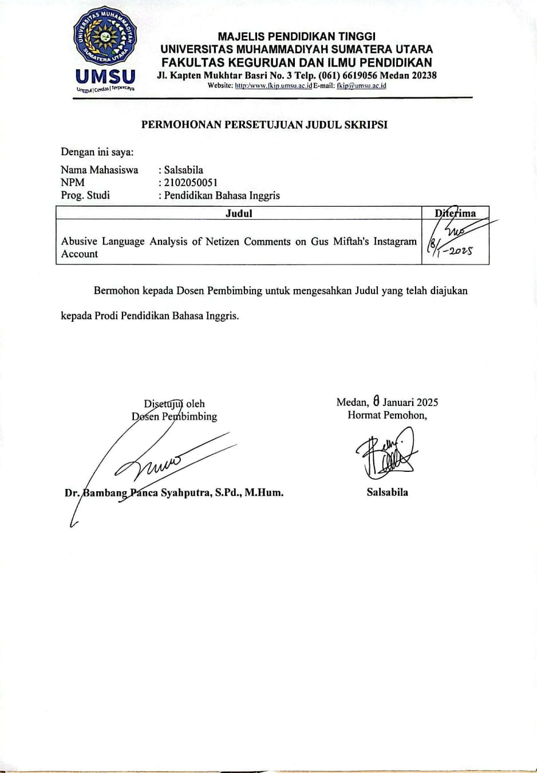
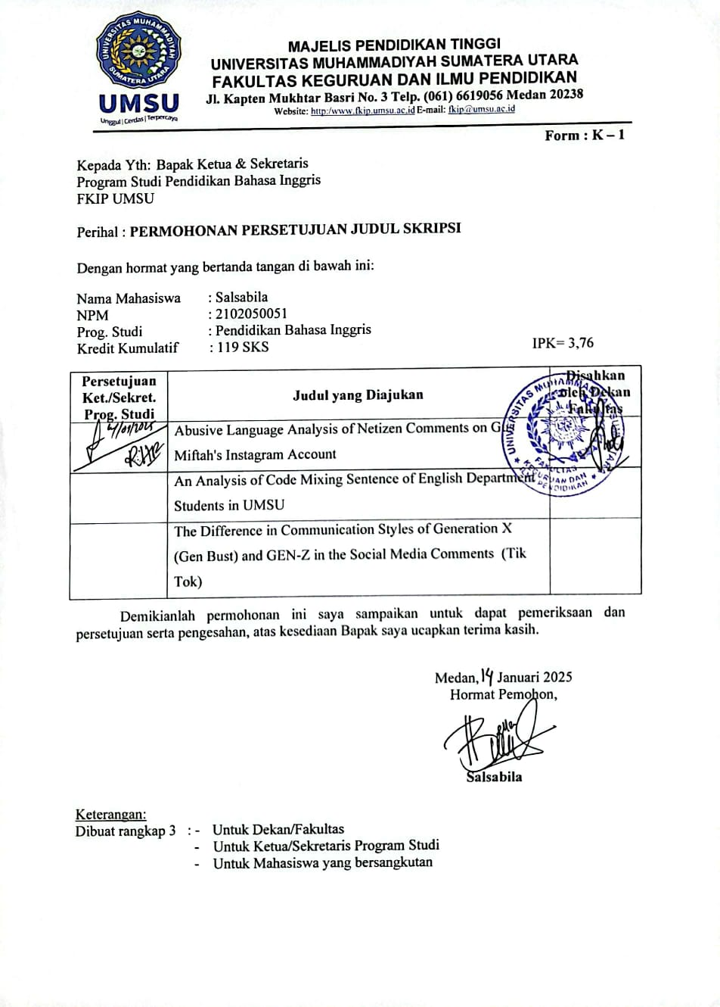
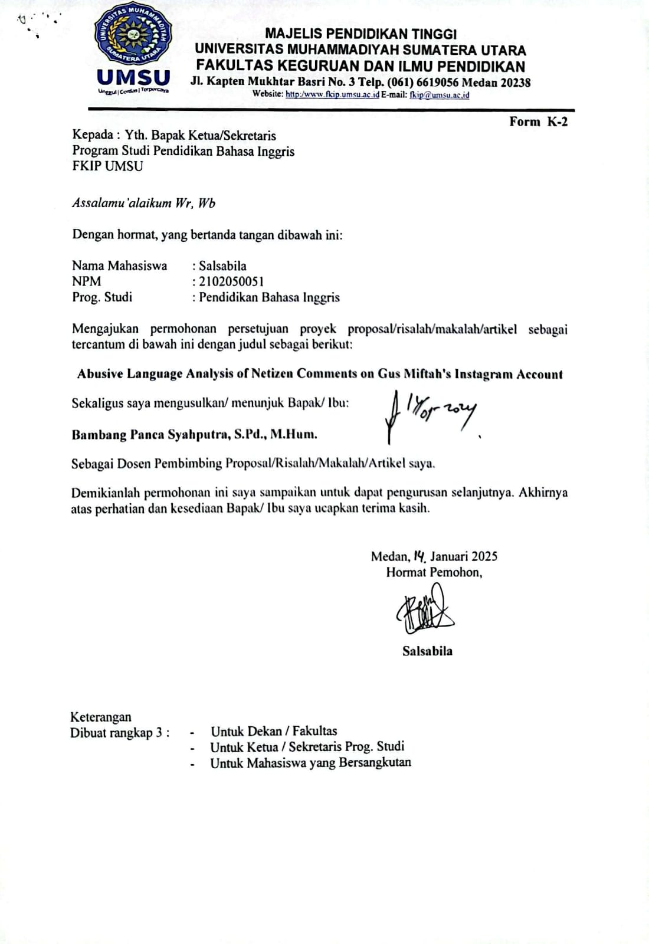
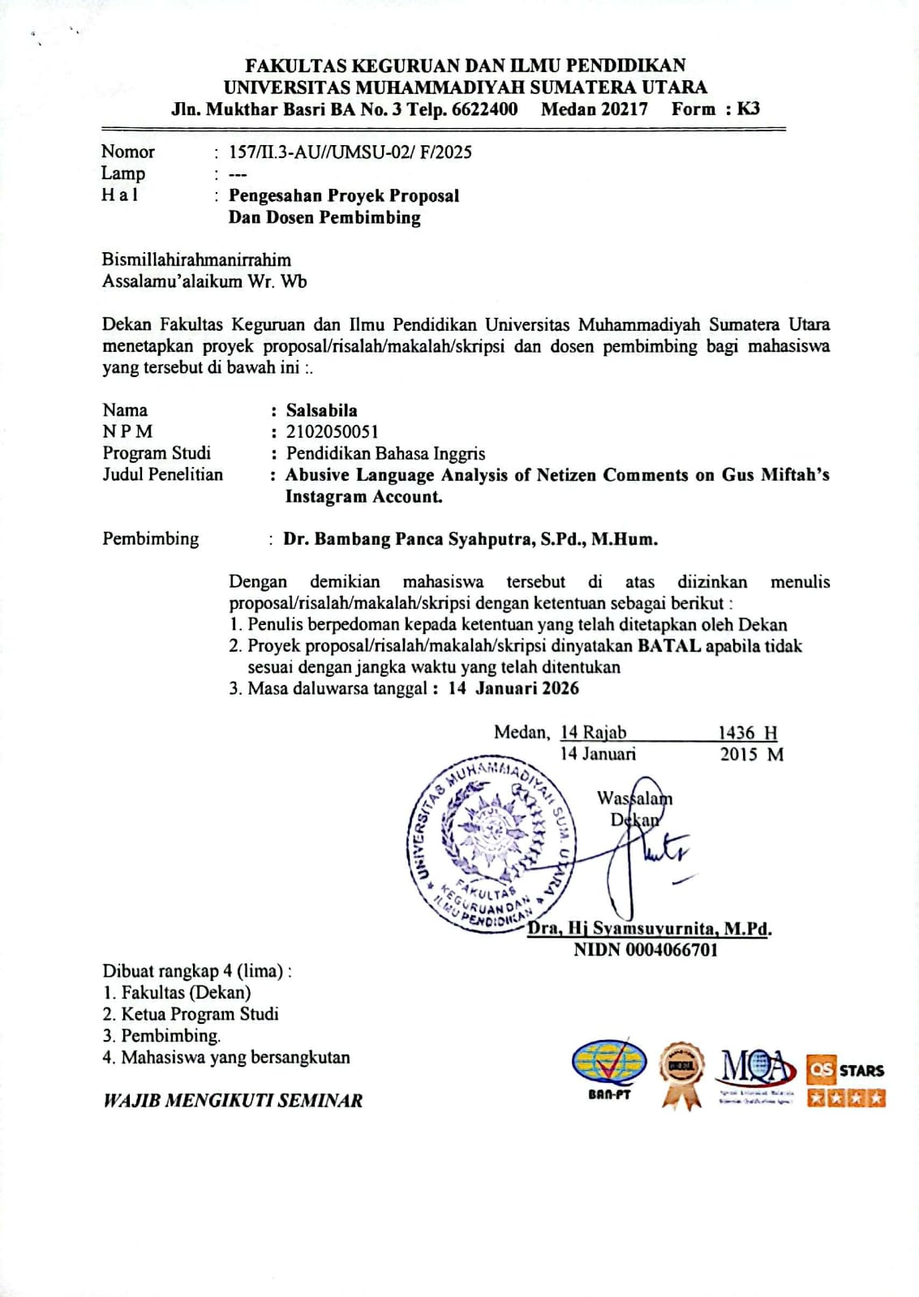
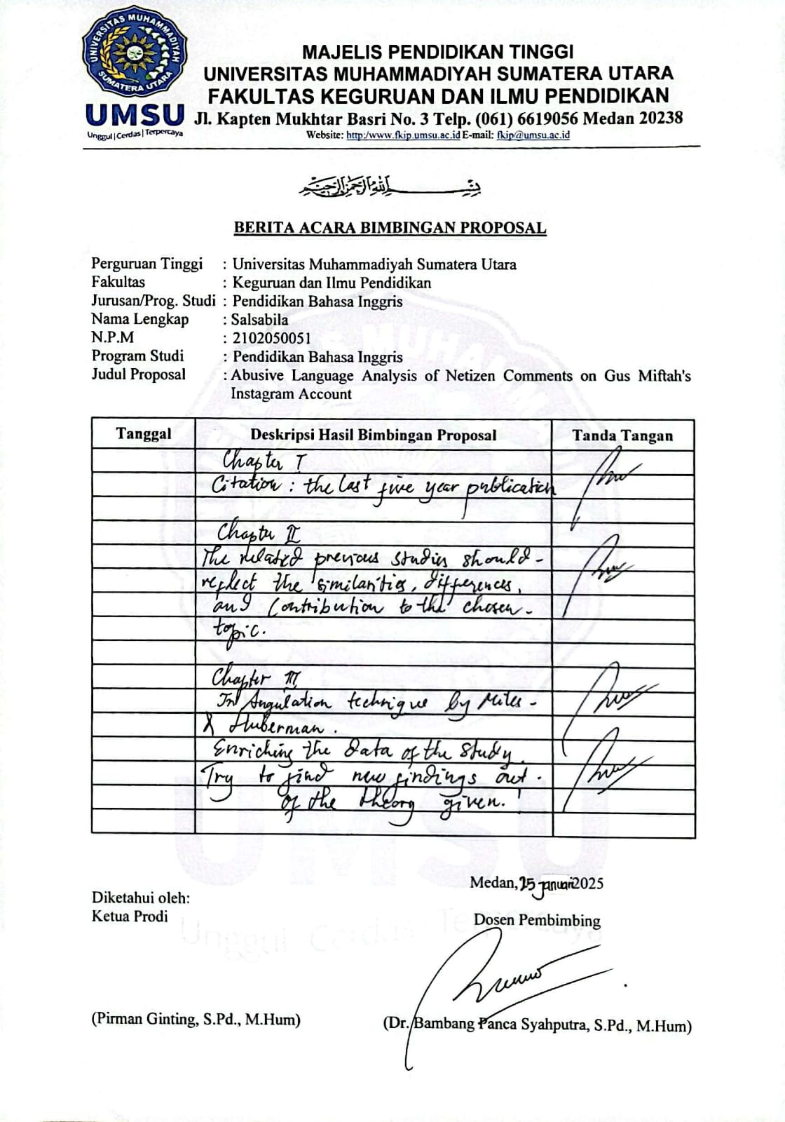
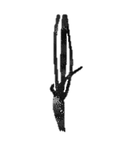

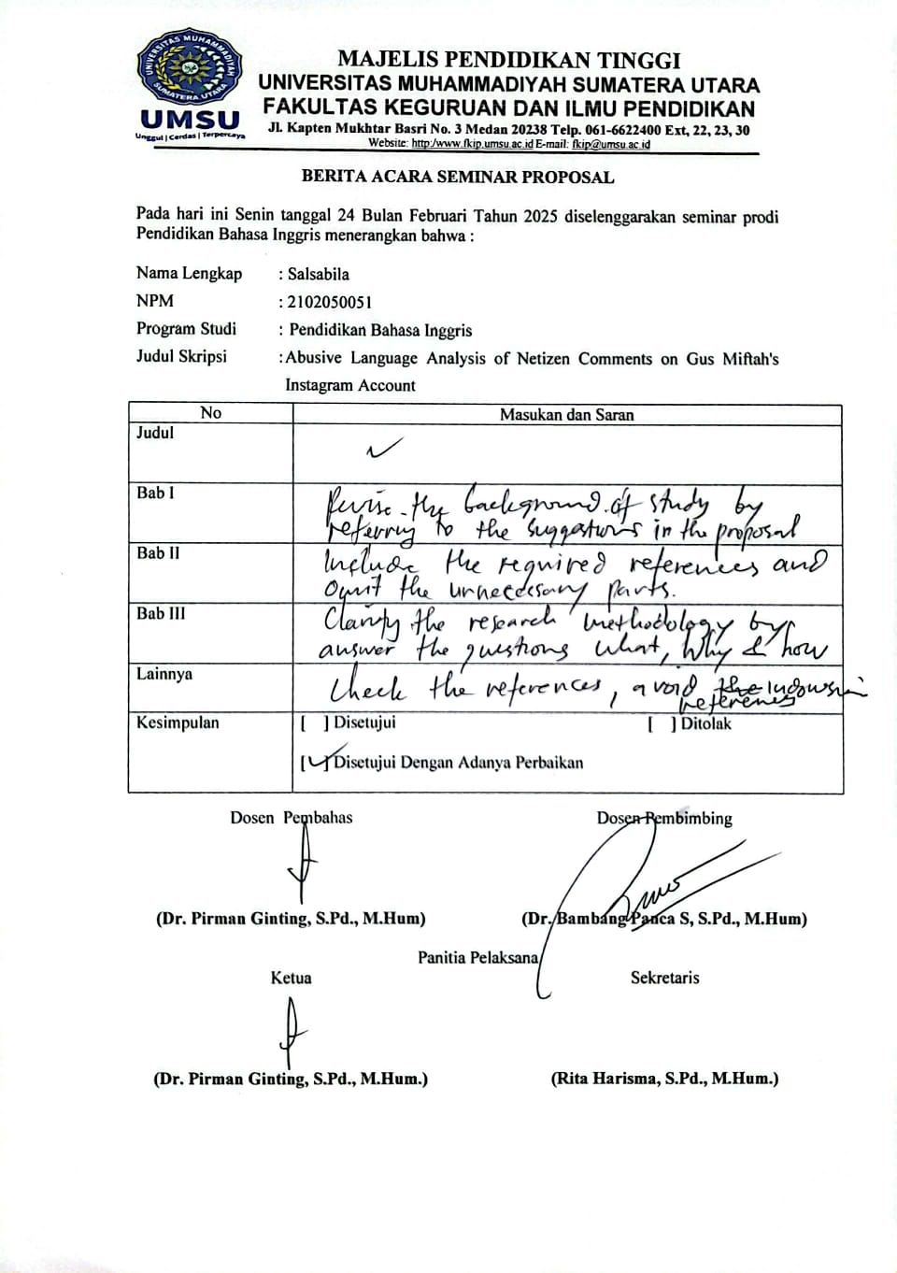
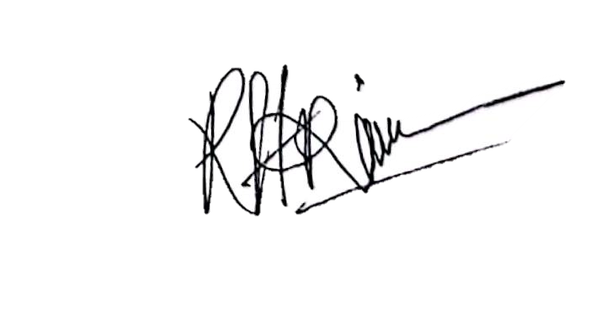
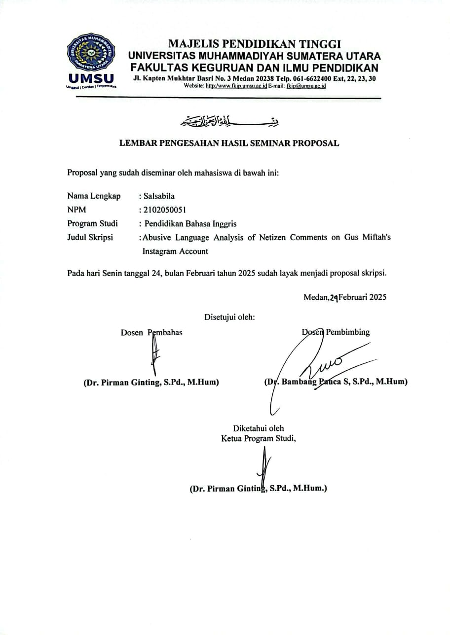
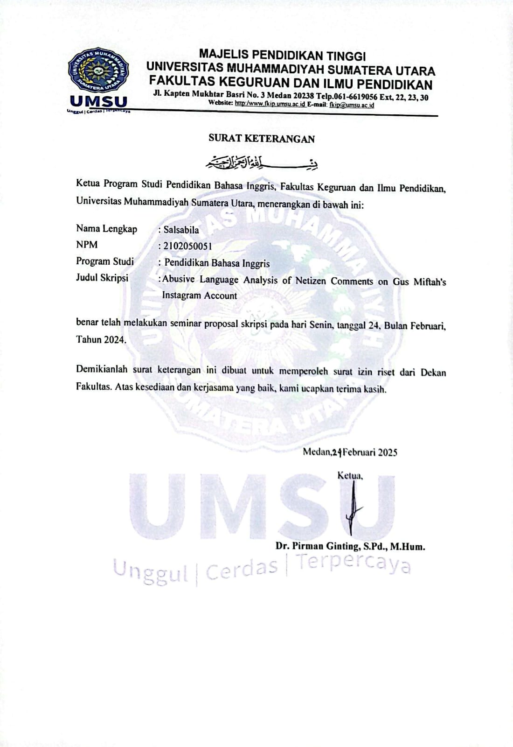

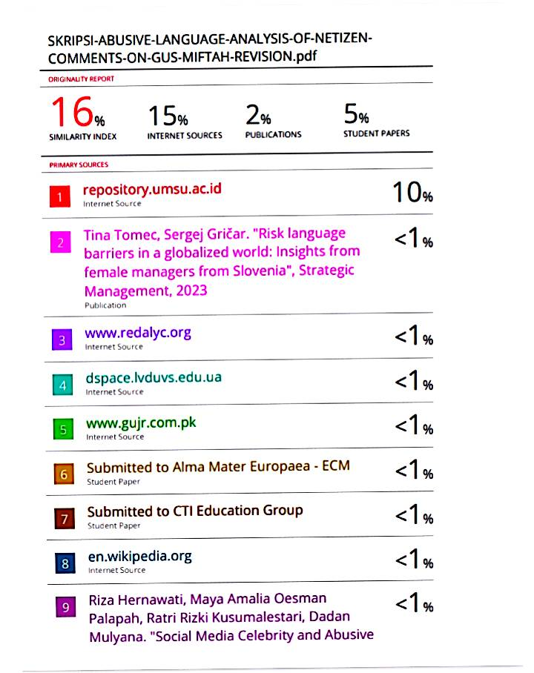
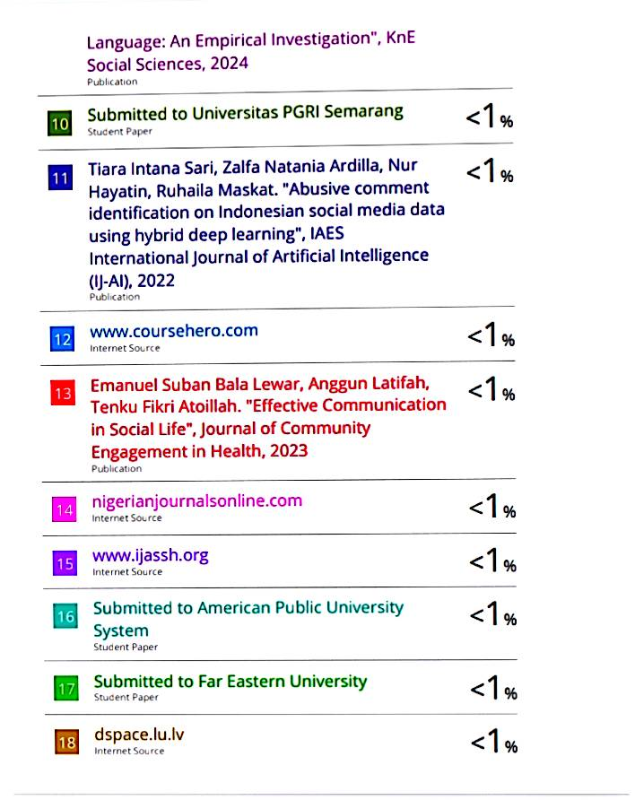
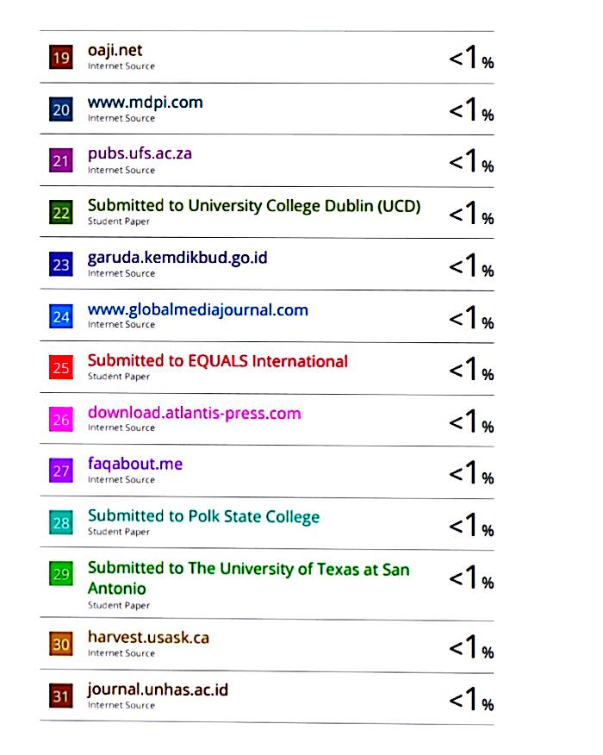
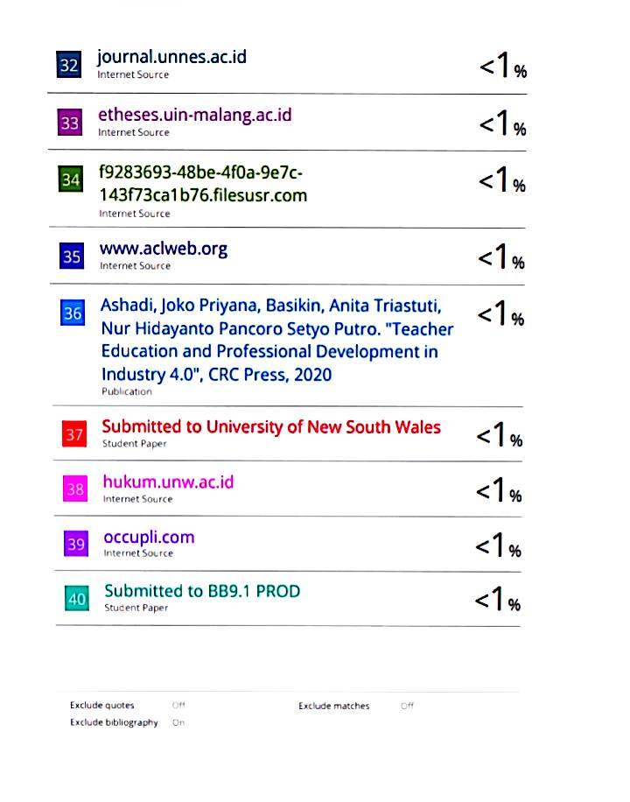
DAFTAR RIWAYAT HIDUP


DATA PRIBADI
Nama : SALSABILA
Jenis Kelamin : Perempuan
Tempat, Tanggal Lahir : P.Brandan. 29 Oktober 2003
Alamat : Jl. Pasar Pompa Air LK.Vll
Kebangsaan : Indonesia
Agama : Islam
Email : bila00705@gmail.com
Nomor Hp: 0813-6994-4343

RIWAYAT PENDIDIKAN
Nomor Perserta Mahasiswa :2102050051
Fakultas : Keguruan dan Ilmu Pendidikan
Program Studi : Bahasa Inggris
Perguruan Tinggi : Universitas Muhammadiyah Sumatera Utara Alamat Perguruan Tinggi : Jl. Kapten Muchtar Basri BA. No.3 Medan

No. Tingkat Pendidikan Nama Dan Tempa Tahun

1. SD | SD Negeri 050769 | 2009 - 2015
2. SMP | MTS’s Darul Arafah | 2015 - 2018
3. SMA | SMA Negeri 1 Babalan | 2018 - 2021
4. Perguruan Tinggi | Universitas Muhammadiyah | 2021 - 2025
 | Sumatera Utara

